Lesson 1: An Economic Way of Thinking

Section 1: Introduction

Why are some people and nations wealthy and others poor? This simple-sounding question has no easy answer. In fact, over the past two centuries, some of the world’s best thinkers have wrestled with it. Their answers have generated many of the ideas and principles at the heart of the social science we call economics.

Among the first to consider this question in depth was a political economist and philosopher named Adam Smith. Born in Scotland, Smith taught at the University of Glasgow and later became Scotland’s commissioner of customs. He is best known for his book An Inquiry into the Nature and Causes of the Wealth of Nations, better known today as The Wealth of Nations.

Smith’s book was published in 1776, the same year the Declaration of Independence was written. The connection between The Wealth of Nations and the Declaration does not stop there. In his book, Smith argued that competition is the key to a healthy economy. Nations prosper when buyers and sellers are free to do business in the marketplace without government interference. In the newly independent and liberty-loving United States, Smith’s ideas about competition and free markets took root and grew vigorously.

In The Wealth of Nations, Smith made many observations about people that still ring true today. For example, Smith observed,

Every man is rich or poor according to the degree in which he can afford to enjoy the necessaries, conveniencies, and amusements of human life.

In his 18th-century prose, Smith made the point that people want not only the basic necessities of life—food, clothing, and shelter—but also things that make life easier, or more convenient, and that entertain them. The more of such things they have, the richer they are, at least in economic terms.

Smith was not the first to explore everyday economic events. But he developed a way of thinking about those events that had a lasting impact and earned him the title “the father of modern economics.” Economists still read The Wealth of Nations to refresh their thinking about fundamental economic principles.

This chapter explores some of these principles and how they can help you develop an economic way of thinking. Along the way, the words of Smith and other economists are included to offer you guidance. The more you learn about how to think like an economist, the better you will become at making sound decisions in almost every area of your life.

Section 2: What is economics all about?

When most people think about economics, they see numbers, graphs, and equations. Indeed, in this book, you will encounter a fair number of graphs and the occasional equation. But that is not what economics is all about. In their popular book Freakonomics, economist Steven Levitt and journalist Stephen Dubner argue that economics "is about stripping a layer or two from the surface of modern life and seeing what is happening underneath." This is what Adam Smith did in 1776 and what economists continue to do today.

Everyday Mysteries and Economic Enigmas
When they strip away a layer from the surface of modern life, economists often uncover curious mysteries and enigmas. These economic enigmas are puzzles or riddles that might be explained through an economic analysis. For economist Steven Landsburg, finding and solving such mysteries is what economics is all about:

First, it is about observing the world with genuine curiosity and admitting that it is full of mysteries. Second, it is about trying to solve those mysteries in ways that are consistent with the general proposition that human behavior is usually designed to serve a purpose.
—Steven E. Landsburg, The Armchair Economist: Economics and Everyday Life, 1993

Some of the mysteries that Landsburg refers to are large and abstract. For example, why does an economy grow for a long time and then start to shrink? Others deal with smaller, everyday enigmas that an ordinary person might wonder about. For example, one question Landsburg pursues is, why does popcorn sold at the movies cost more than at a grocery store? Another is, why are so many products sold for $2.99 and so few for $3.00?

Not all economists think of their job as investigating economic enigmas. But most would agree that economics has a lot to do with asking questions that reveal what the Freakonomics authors call "the hidden side of everything."

How People Use Limited Resources to Satisfy Unlimited Wants
Economics has traditionally been defined as the study of how people—individually and in groups—choose to use their limited resources to satisfy their unlimited wants. This concept of economics goes back at least to the ancient Greek author Xenophon, whose book Oeconomicus described how a household should manage its resources.

A resource is anything used to produce an economic good or a service. Resources are limited, or scarce, because they exist in finite amounts. Only so many workers, minerals, machines, and other resources can be used at any given time to produce goods and services. Resources also have alternative uses. Trees, for example, can be used to build houses, to make paper, or to burn for fuel.

Despite the scarcity of resources, people’s wants are unlimited. At any one moment, we may have enough of certain things to satisfy us. But we would still like more of other things. Even the wealthiest people want more—perhaps a fancier vehicle or a bigger home.

Economists divide their study of how people use their scarce resources into two main branches. Microeconomics looks at economic decision making by individuals, households, and businesses. Macroeconomics focuses on the workings of an economy as a whole.

Economists look at how individuals and whole societies try to satisfy their unlimited wants given their limited resources. This issue is so central to human existence that Alfred Marshall, an influential 19th-century economist, described economics as “a study of mankind in the ordinary business of life.”

The Science of Decision Making
Look again at the traditional definition of economics. Notice that it also involves studying how people choose to use their resources. When people cannot have everything they want, they must make choices. Some economists argue that economics is mainly about how we make these choices. They would define economics as the science of decision making.

As a consumer, you are continually making decisions. Should you buy a sandwich or a salad for lunch? If a salad, should it be lettuce or spinach? Should you top it with tomatoes, onions, or peppers? What about the dressing? These decisions may seem relatively trivial. But what about larger decisions, such as should you look for a weekend job? Or should you accept a credit card offer you got in the mail? Economists have developed ways of thinking about such choices that can lead to better decision making.

What Is and What Should Be: Positive Versus Normative Economics
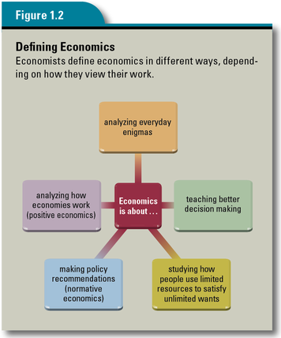
Economists spend a great deal of time describing how things are and why. But sometimes, they are also asked to offer advice on what should be done to make things better. Consider the following two questions, which a school board facing a budget crisis might ask of an economic analyst:

Question 1: What impact will increased enrollment, salary increases, and rising maintenance costs have on next year’s budget?
Question 2: What actions should we take now to reduce expenses in order to balance next year’s budget?

To answer the first question, the economic analyst would gather facts about the number of new classes needed to cope with rising enrollment, the salaries of school employees, maintenance costs, and other expenses. This type of analysis, which describes how things are, is known as positive economics.

To answer the second question, the economic analyst would not only gather facts but also analyze the various choices the school board has for cutting costs. Having laid out the choices and their possible impacts, the analyst would then make a recommendation to the board on where to cut costs. This type of analysis, which focuses on how things ought to be done, is known as normative economics.

Most economists are engaged in positive economics. But many others have taken on the role of policy advisers to government officials. In this role, they go beyond the objective facts to recommend actions based on what they believe to be the best way to achieve the officials’ desired objectives.

Section 3: What seven principles guide an economic way of thinking?

People often think of economics as a limited field of study concerned with money, taxes, banking, and trade. These subjects are central to economics. But in studying them, economists have developed principles that apply to much more than money or business. Taken together, these principles represent an economic way of thinking about the wider world. This way of thinking can help you see ordinary events in a new way—sort of like putting on a special pair of glasses. Try looking for these principles as you take an imaginary summer road trip. Try to see events along the way as an economist might see them.

Principle 1: Scarcity Forces Tradeoffs
This first principle recognizes that although our desires for things are unlimited, the resources needed to fulfill our desires are scarce. Because of this scarcity of resources, there will never be enough of everything to satisfy everyone completely. We will always be forced to make choices as to what we want most. Whenever you choose one thing over another, you are making a tradeoff. You are giving up one thing to get another that you want even more. The scarcity-forces-tradeoffs principle reminds us that limited resources force people to make choices and face trade-offs when they choose.

Economists have another name for the scarcity-forces-tradeoffs principle: the no-free-lunch principle. This name stems from the observation that every choice—even that of accepting a free lunch—involves tradeoffs. Even if the lunch was free to you, someone had to pay for the meal. And in making that choice, that someone had to go without something else. Looked at in this way, there is no such thing as a “free” lunch.

You may not realize it, but you make choices all the time based on the scarcity-forces-tradeoffs principle. What, for example, should you do next summer? Should you get a job at the mall? The pay might be good, but the work might be boring. Should you find an internship in a career area that interests you? The pay might be low, but the experience could be valuable. Should you volunteer to help build housing for the homeless? Although there is no pay, you would like working with your hands and helping others. Time is scarce. You can take only one of these jobs. Will it be good pay, valuable work experience, or a sense of satisfaction from helping others? The tradeoff for choosing one alternative is giving up the other two.

Now consider another option for the summer after you graduate—a road trip with your best friend to follow your favorite band on tour. How might the scarcity-forces-tradeoffs principle come into play if you were to buy a used car for the trip? Say you find two cars that fit your budget. One is a luxury sedan that averages 15 miles per gallon of gas. The other is an economy model that gets nearly twice the mileage of the large sedan. You cannot buy both. In making a choice, you will have to trade off roominess for good gas mileage or the other way around.
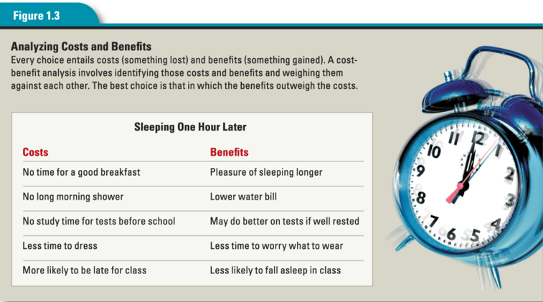

Principle 2: Costs Versus Benefits
The scarcity-forces-tradeoffs principle forces us to make choices. But how do we decide which alternative to choose? Economists assume that individuals make choices based on the expected costs and benefits. The costs of something are what you spend in money, time, effort, or other sacrifices to get it. The benefits are what you gain from something in terms of money, time, experience, or other improvements in your situation. The costs-versus-benefits principle tells us that people choose something when the benefits of doing so are greater than the costs.

To calculate costs and benefits, economists use a tool known as a cost-benefit analysis. This analysis might begin with a formal listing of the costs and benefits involved in a choice, as shown in Figure 1.3. Or it might be a quick, informal assessment of the costs and benefits. Either way, the analysis should lead to a calculation of which side “outweighs” the other. For example, what are the costs of sleeping an hour longer on a school day? Would you not take a hot shower? Would you lose out on study time? What benefits might you gain? Would you get needed rest or have more energy? A rational choice is one in which the benefits are greater than the costs.

Think about how the costs-versus-benefits principle might come into play during your proposed road trip. Each evening, you and your friend face the choice between pitching a tent at an inexpensive campground or paying more for a motel room with a soft bed and a shower. Your decision would depend on your own analysis of the costs and benefits of each arrangement. The choice here is personal. Do the benefits of renting a motel room outweigh the higher cost?

Principle 3: Thinking at the Margin
Most everyday choices involve thinking in terms of a little more of this or a little less of that, rather than all or nothing. For example, you may find yourself having to decide whether to study one more hour, buy one more shirt, or eat one more slice of watermelon. In economic terms, when we decide to add (or subtract) one more unit to (or from) what we already have, we are thinking “at the margin.” The margin, in this case, is the border or outer edge of something. The thinking-at-the-margin principle tells us that most of the decisions we make each day involve choices about a little more or a little less of something rather than making a wholesale change.

Making decisions at the margin involves comparing marginal costs and benefits. The marginal cost is what you give up to add one unit to an activity. The marginal benefit is what you gain by adding one more unit. Suppose you have just spent two hours studying for an economics test. Should you study another hour or go to bed? The answer depends on whether you think the marginal benefit of the extra hour of sleep—maybe doing a bit better on the test—will exceed the marginal cost of that hour—perhaps being less well rested for the test.

Now think about your road trip. You and your friend have organized your trip around all six cities where your favorite band is performing. But then the band announces that it is extending its tour to one more city. The added concert is not in your plans, but you would really hate to miss it. Here is a decision you must make at the margin. Is the marginal benefit of attending the seventh concert worth the added costs in time and money?

Principle 4: Incentives Matter
As we have seen, costs and benefits influence our behavior. That is, they act as an incentive, something that motivates a person to take a particular course of action. The incentives-matter principle simply says that people respond to incentives in generally predictable ways.

When economists want to understand why people do what they do, they start looking for incentives. This principle led Landsburg to write, “Most of economics can be summarized in four words: ‘People respond to incentives.’” Levitt and Dubner would agree:

Incentives are the cornerstone of modern life. And understanding them—or, often, ferreting them out—is the key to solving just about any riddle, from violent crime to sports cheating to online dating.
—Steven D. Levitt and Stephen J. Dubner, Freakonomics, 2006

Why, for example, would hundreds of people stand in line on a city sidewalk in the heat of summer for several hours just to get a concert ticket? Certainly they would not behave this way without some sort of powerful incentive.

Incentives come in many forms, both positive and negative. Teachers use points and grades as positive incentives to encourage students to complete their assignments. Honor societies and awards are also positive incentives used by schools to motivate students to achieve their highest levels.

Governments use negative incentives, such as fines and jail time, to discourage people from breaking laws. You are reminded of this one morning when your road trip hits a speed trap. While driving along, you suddenly see a police motorcycle with flashing lights behind you. The officer tells you that you were driving 65 miles per hour in a 50-mile-per-hour zone. Worse yet, you were in a construction zone, where fines are doubled. Your decision to ignore the speed limit signs will cost you a hefty $150 fine. You decide that is more than enough incentive for you to watch your speed from now on.

Principle 5: Trade Makes People Better Off
Why doesn’t your family make all its own clothes, build all its own furniture, grow all its own food, and produce its own medicines? Adam Smith answered that question two centuries ago:

It is the maxim of every prudent master of a family never to attempt to make at home what it will cost him more to make than to buy. The taylor [tailor] does not attempt to make his own shoes, but buys them of the shoemaker. The shoemaker does not attempt to make his own clothes, but employs a taylor.
—Adam Smith, The Wealth of Nations, 1776

As Smith understood, none of us is equally skilled at doing everything. Nor should we try to be. It makes more sense to concentrate on what we do best and then trade with others for what they do best. The trade-makes-people-better-off principle tells us that by focusing on what we do well and then trading with others, we will end up with more and better choices than by trying to do everything for ourselves.

Your road trip gives you a firsthand appreciation of this principle when you run into car trouble. One morning, you turn the key and nothing happens. Neither you nor your friend is a mechanic, so you push the car to the nearest gas station and look for help. The mechanic on duty quickly diagnoses the problem as a dead battery. You offer to trade your two tickets for that night’s concert for a new battery. The mechanic agrees, and your car is soon running again. You are disappointed about missing the concert, but everyone involved agrees that trading the battery for the tickets makes you all better off than you were that morning.

Principle 6: Markets Coordinate Trade
When you think of markets, you probably conjure up the image of a supermarket or farmers market. Economists take a more expansive view of markets. To them, a market is any arrangement that brings buyers and sellers together to do business with each other. A market can exist in a single place, like a weekend flea market. Or it can exist in cyberspace, such as an online auction site.

When markets operate freely, or with limited government interference, buyers and sellers can trade with each other until both are satisfied with their sales and purchases. The result is an efficient market that serves everyone’s interests without guidance from a person or an institution. Themarkets-coordinate-trade principle states that markets usually do better than anyone or anything else at coordinating exchanges between buyers and sellers.

Just how markets do all this coordination was not clear to people in Adam Smith’s day. He used the metaphor of an invisible hand guiding human affairs to explain this mystery. On your road trip, you feel the invisible hand at work when you visit a supermarket. As you push your cart through the aisles, you see fresh mangos from Mexico, bananas from Belize, shrimp from Thailand, cheese from France, and salmon from Alaska. You wonder how a grocery store manages to stock its shelves with so many fresh foods from around the world at prices you are willing to pay. The answer is simple: markets coordinate trade with remarkable efficiency.

Principle 7: Future Consequences Count
In general, people are shortsighted. They tend to make decisions by looking only at the immediate costs and benefits. But decisions made today often have longer-term effects that should also be considered. The future-consequences-count principle tells us that decisions made today have consequences not only for today but also in the future.
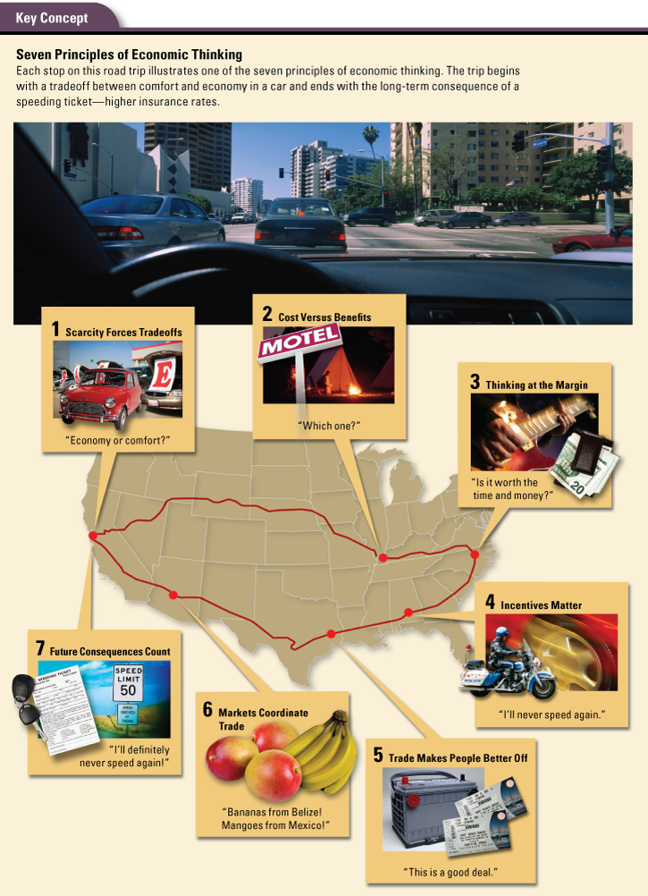
To economist Henry Hazlitt, this principle separates the good economist from the bad. He wrote,

The bad economist sees only what immediately strikes the eye; the good economist also looks beyond. The bad economist sees only the direct consequences of a proposed course; the good economist looks also at the longer and indirect consequences . . . The art of economics consists in looking not merely at the immediate but at the longer effects of any act or policy.
—Henry Hazlitt, Economics in One Lesson, 1979

Part of thinking like an economist involves trying to imagine all the possible consequences of a decision. But nothing about doing this is easy. Consider a law passed in 1968 in Vermont that banned roadside billboards and other large signs in order to protect the state’s scenic beauty. Since then, businesses have instead built sculptures, including a giant squirrel in red suspenders and a 19-foot-high genie, to attract the attention of passersby.

The result of the Vermont law was an example of what economists call the law of unintended consequences. This law says that actions of people and governments always have effects that are not expected, or that are “unintended.” Economists spend much of their time trying to predict these unintended consequences.

Your decision to take a road trip had a variety of consequences—some intended, others not. In the short term, you found out what it was like to be on your own, away from your family. You learned a lot about being independent, handling difficult situations, and making your own way in the world. When you open your insurance bill months later, however, you realize that your trip has had a long-term, unintended consequence. The cost of your insurance has gone up because one day last summer you chose to ignore a speed limit sign.

Section 4: What tools do economists use?

The law of unintended consequences illustrates just how complicated—and frustrating—the work of an economist can be. You might wonder why economists do not just throw up their hands and say, “I quit!” But economists actually like their job and enjoy solving economic enigmas.

To do their job properly, economists need ways to examine economic events, to simplify them, and to figure out how a given economic decision can affect the world. To do this, they need a set of tools. Three of the most effective tools that economists use are the scientific method, graphs, and economic models.

The Scientific Method: Question, Hypothesize, and Observe

You are no doubt familiar with the first tool, which you probably began learning in elementary school. As shown below, the scientific method involves posing a question, researching the question, developing a hypothesis, conducting studies and collecting information, analyzing the information, and then evaluating the hypothesis. You may have applied the scientific method by growing bean plants, examining bacteria under a microscope, or measuring waves in a wave tank. Through such laboratory experiments, you collected data, or factual information, that gave you vital insights into the physical world and its processes.
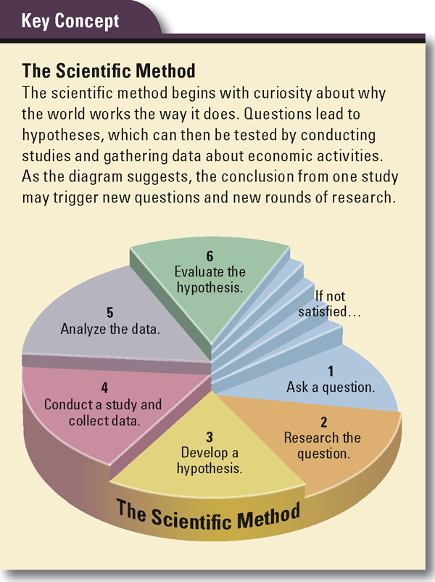
Economists, like other scientists, rely on the scientific method to study how the world works. But they have a big handicap. Usually, they cannot conduct laboratory experiments to make observations or test their theories. For example, an economist might have a theory that raising highway speed limits would improve the economy, in part by enabling the speedier transport of goods from farms and factories to stores. But how might she test that theory? It is highly unlikely that government officials would permit an economist to turn the highway system into a huge laboratory.

When economists lack experimental data, they have to be satisfied with whatever data society naturally provides. For this reason, economists have become skilled at analyzing existing and historical data. As it happens, a law that was passed in 1974 resulted in a national maximum speed limit of 55 miles per hour. In 1995, Congress repealed the law, allowing each state to set its own maximum speed. Many states raised their limits, giving economists the chance to analyze how transportation costs varied before and after the speed limit changed.

Through such “natural experiments,” economists have learned what kinds of data are important and have developed ways to examine those data. As economist Steven Levitt noted, “Knowing what to measure and how to measure it makes a complicated world much less so.”

Graphs: Two-Dimensional Representations of a Three-Dimensional World
Graphs are useful tools for analyzing and displaying data. A graph is a visual representation of the relationship between two given sets of data. One or both sets of data are also known as variables. A variable is a quantity that can vary, or change.

Economists use two-dimensional graphs to simplify the complex, three-dimensional world in which we live. Because it is a simplification, a graph may not yield a complete picture of how two sets of information are related. Nonetheless, it gives economists an important tool for examining the relationship.
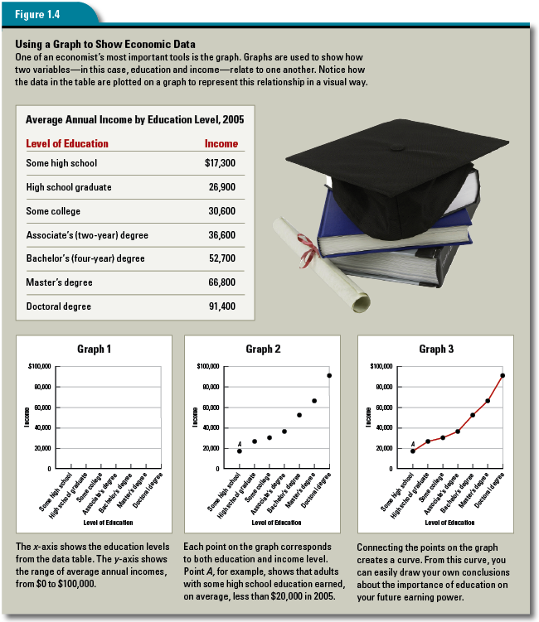
Consider how economists might analyze the relationship between the amount of education a person has and that person’s annual income. They would start by gathering information. The table in Figure 1.4 shows data for the year 2005.The two variables in this table are level of education and income. Each dollar figure in the table represents the average annual income of every person at that education level who had an income in 2005.

The same data can be plotted on a coordinate system, like the graphs shown with the table. A coordinate system consists of two perpendicular lines that can be used to locate a point in space. Each of the two perpendicular lines is called an axis. The horizontal line is the x-axis, and the vertical line is the y-axis.
Once the data in the table are plotted as a set of points in the coordinate system, the points can be joined to form a curve. A curve is any line representing data points plotted on a graph. As you can see in Graph 3 in Figure 1.4, a curve doesn’t have to be curved. In fact, straight lines on a graph are also called curves. The shape of this curve tells us that, on average, the more education people have, the higher their incomes will be.

As useful as graphs are at representing relationships, they have their limitations. The graphs in Figure 1.4 do not, for example, shed light on factors other than education that might have affected income in 2005. Suppose an unusually harsh winter had slowed construction projects and delayed spring planting across the country that year. The impact of such a slowdown would have fallen most heavily on construction workers and farm workers, many of whom lack college degrees. As a result, their 2005 incomes would have been lower than usual for reasons quite unrelated to education.

Economic Models: Simplified Representations of Reality
Economists use models to help them understand how the world works. An economic model is a simplified representation of reality that often allows economists to focus on the effects of one change at a time. Models also help economists structure their thinking. A model can take the form of an equation, a computer program, or a diagram. It can also consist mainly of a written description.

One widely accepted descriptive model is called homo economicus. This is Latin for “economic man,” although it applies to all human beings. It is also called the rational-behavior model. This model is a tool for understanding the mystery of human behavior. It theorizes that people behave in ways that are rational, or based on reason. That is, people make decisions that they think will fulfill their wants and needs to the greatest extent possible. They behave in ways that serve their own interests, without taking into account the well-being of others.

The rational-behavior model, with its focus on self-interest, arose after the time of Adam Smith. But the pursuit of self-interest plays a key role in Smith’s descriptions of the free market. As if guided by an “invisible hand,” self-interested market activity ends up benefiting all of society. This is the point Smith made in describing the typical businessperson:

It is his own advantage, indeed, and not that of the society, which he has in view . . . He intends only his own gain, and he is in this, as in many other cases, led by an invisible hand to promote an end which was no part of his intention.
—Adam Smith, The Wealth of Nations, 1776

Models are an approximation of how people, in general, act. As such, models cannot accurately predict all behavior all of the time. Economists who construct models must make assumptions. Consider the model just described, which assumes that people always act for their own benefit. Economists know that the rational-behavior model does not deal with social values, such as charity, that might curb self-interest. Nor does it deal with decisions based on limited or false information.

Faced with these missing factors, the economist shrugs and says, “Ceteris paribus,” which is Latin for “other things being equal” or “other relevant factors remaining unchanged.” This is the economist’s way of saying, “Let’s focus on understanding what happens if we change one aspect of the mystery and keep all other aspects the same.” The economist thinks, “Maybe if I can understand this one aspect, I can begin to understand the larger mystery.” The point of economic models is to aid in examining economic effects, one change at a time, and in making predictions about the consequences of that change.

Good economic models are useful for both explaining and predicting how the economy operates. The rational-behavior model works pretty well at predicting how people generally react to incentives or how they use cost-benefit analyses to make decisions. By and large, we do these things without even consciously thinking about them. When this happens, we are behaving as this economic model would predict.

According to this model, humans make decisions based on their own best interests. So, is thinking like an economist in your best interest? Certainly it is, if it helps you make better decisions. You have had a brief introduction to the principles and tools that help economists look at the world in a special way. In the rest of this book, you will use those principles and tools to develop your own understanding of how the world works. In the process, you will become a better consumer and citizen. That seems like a pretty good tradeoff for the time you will spend in this course.
Summary

Economics is both a social science and a way of thinking about how the world works. It can help us unravel everyday mysteries and make better decisions about matters large and small.

What is economics all about? Economics is the study of how individuals and societies use their limited resources to satisfy their unlimited wants. Positive economics looks at the way things are and why. Normative economics looks at the way things ought to be. In examining how people make decisions about production and consumption, economists attempt to get beneath the surface of everyday life.

What principles guide an economic way of thinking? Economists have identified several principles that can help us understand how people make choices and how their decisions affect others. They include the following:
• scarcity forces tradeoffs
• benefits should outweigh costs
• decisions are often made at the margin
• incentives matter
• trade makes people better off
• markets coordinate trade better than anything or anyone else
• decisions made today have consequences in the future

What tools do economists use? Economists use the scientific method to analyze economic events and predict outcomes. They use graphs to analyze the relationship between two sets of data. They also use economic models to better understand how the world works. An economic model can take various forms, such as a diagram, an equation, or a description.

