Lesson 8 - Parties, Interest Groups, and Public Policy

Section 1 - Introduction
In the summer of 2004, the United States was gearing up for presidential elections. As the race for president heated up, political ads appeared on television screens across the country. Many of these ads featured the leading candidates of the two major parties, Republican George W. Bush and Democrat John Kerry.
One ad showed President Bush at a campaign rally in Ohio. He was comforting a 16-year-old girl who had lost a parent in the 9/11 terrorist attacks on New York City’s World Trade Center. “He’s the most powerful man in the world,” said the girl in the ad, “and all he wants to do is make sure I’m safe.”
In another ad, a high-powered assault rifle flashed across the screen. A voice-over explained that in the hands of terrorists, this gun “could kill hundreds—that’s why they’re illegal.” The ad shifted to images of John Kerry as the announcer explained that Kerry supported a ban on these weapons, while his opponent did not. “George Bush says he’s making America safer,” the announcer intoned. “Who does he think he’s kidding?”
Most people watching these advertisements probably assumed that they came from the political parties [political parties: an organization that seeks to achieve power by electing its members to public office] that sponsored the candidates or from the candidates themselves. Only those paying close attention to the credits knew otherwise.
In fact, a conservative interest group [interest group: any organized group whose members share a common goal and try to promote their interests by influencing government policymaking and decision making] called Progress for America funded the pro-Bush ad. The Kerry ad was paid for by the liberal interest group MoveOn.org. Although neither ad specifically asked viewers to vote for a particular candidate, the sponsors of these commercials clearly hoped to influence the 2004 election.
Increasingly, interest groups have joined political parties as key players in the American political process. Both types of organizations are actively engaged in politics, providing information to officials and the public and seeking to affect the outcome of elections. This chapter examines parties and interest groups and considers their influence on our political system today.

Section 2 - Political Parties in the United States
Political parties have played an important role in American politics since the early years of the Republic. Yet many of the nation’s founders did not approve of parties. In his Farewell Address of 1796, George Washington warned against “the baneful effects of the spirit of party.” He believed that parties would divide the American people and have a negative influence on government.
John Adams and Thomas Jefferson shared Washington’s concern. Adams said, “There is nothing which I dread so much as the division of the Republic into two great parties . . . in opposition to each other.” Jefferson claimed, “If I could not go to heaven but with a party, I would not go there at all.” Nevertheless, both men eventually became leaders of political parties, and the party system itself became entrenched in American politics.

What Do Political Parties Do in a Democracy?
The primary goal of parties is to get their candidates elected to office. However, they also have a number of other functions, some of which are listed below.
Parties recruit candidates and support campaigns. Each year, political parties seek out and enlist candidates to run for thousands of local, state, and national offices. They look for people with the skills to run a successful electoral campaign and to be effective in office. Political parties also provide some funding for candidates.
Parties help organize elections and inform voters. Although state and local governments run elections, political parties help by promoting voter interest and participation. They register voters and monitor the polls on Election Day. They also help inform voters on political issues.
Parties organize the government. Congress and most state legislatures are organized along party lines. After congressional elections, members of the majority party in Congress choose one of their members to be speaker of the house or Senate majority leader. Committee chairpersons in Congress also come from the majority party.
Parties unite diverse interests and make collective action possible. Parties bring diverse groups together by building coalitions based on shared beliefs and common goals. Delegates attending national party conventions create platforms [platform: a political party’s statement of principles and objectives] that outline the party’s position on important issues. In that process, they seek to balance the interests and concerns of members from across the country. Their goal is to produce a document that all party members can unite behind to achieve their shared political objectives.
Parties serve as a loyal opposition to the political party in power. The goal of a political party is to win control of the government so that it can translate its objectives into laws and policies. The party not in power, or the minority, serves as a “loyal opposition” to the majority party. Minority party members act as critics of the majority party’s proposals. They also serve as government watchdogs, always on the lookout for corruption or abuses of power.
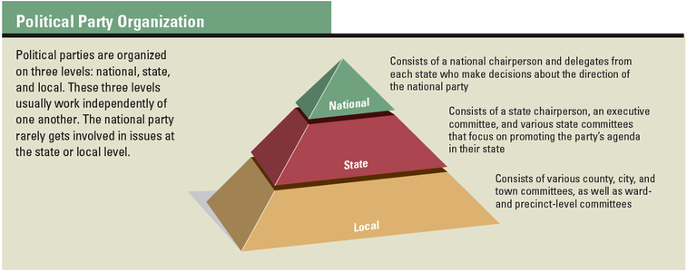

The Structure of Political Parties: Local, State, and National
Both major political parties in the United States are organized at the local, state, and national level. Committees manage the affairs of the party at each level. The diagram below shows the basic organization of a major political party.
The national committee is made up of delegates from each state. A national chairperson oversees the day-to-day operations of the committee. The chairperson also makes public appearances to raise support for the party and improve its chances in upcoming elections.
The organization of state and local committees mirrors the structure of the national committee. Each state has a central committee with a chairperson. Beneath the state committee are various county committees. Some states also have committees at the city, town, or precinct [precinct: a local voting district of a city or town] level. A precinct is a local voting district.
Political parties offer various ways for citizens to get involved in politics. The most common way is through voter registration. Most Americans identify with one party or the other, and they register to vote as a member of that party. Citizens can also donate money to a political party or its candidates and attend party rallies or meetings. In addition, some citizens volunteer to work on party committees or individual campaigns.
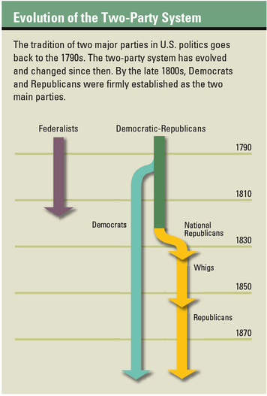

The Evolution of the Two-Party System
In 1787, when the Constitution was written, no political parties existed in the United States. Perhaps this is why the Constitution makes no mention of parties. Before long, however, the nation’s leaders had begun to divide into factions, or groups with differing views. These factions soon gave rise to the nation’s first political parties. By the early 1800s, a political system based on two major parties was beginning to emerge. This two-party system [two-party system: a political system in which two parties dominate the electoral process and control the government] has endured to the present day.
The first parties formed around two powerful figures in President Washington’s administration. Alexander Hamilton and his followers became known as Federalists. They favored a strong national government and drew their support largely from commercial and industrial interests in northern cities. Thomas Jefferson and his supporters, known as Democratic-Republicans, favored a much weaker national government and strong state governments. They gained the backing of farmers and rural interests in southern states.
In 1796, John Adams, a Federalist, succeeded Washington in office. Four years later, however, Adams lost the election to Jefferson. After that defeat, the Federalist Party declined and, within a few years, disappeared altogether.
For a brief time, one party—the Democratic-Republicans—dominated U.S. politics. In the 1820s, however, disgruntled members broke away and formed a new political faction. First called National Republicans, the new faction later became known as the Whig Party. Around the same time, the remaining Democratic-Republicans became known simply as Democrats.
In the 1850s, the issue of slavery deeply divided the Whigs, and their party soon fell apart. A number of former Whigs joined with antislavery activists to form the Republican Party in 1854. During the Civil War and the presidency of Abraham Lincoln, the Republicans established themselves as the nation’s second major party. The Democratic and Republican parties have dominated American politics ever since.

The Two-Party System Today
Over the years, the two parties have evolved and changed, and so have their bases of support. For example, the Democrats were once the strongest party in the South. Today the Republicans generally enjoy more support among southern voters.
In 2000, political analysts began to speak of a deep regional divide in American politics. The results of presidential elections that year showed clearly defined “red states” and “blue states.” The red states—mainly in the southern and central parts of the country—were those in which the majority of people voted Republican. The blue states—mainly in the Northeast and far West—were those in which the majority voted Democratic. The distribution of red and blue states led many political observers to conclude that the United States had become deeply divided along political lines. The map on this page shows the results of the 2000 presidential election.
This red-state, blue-state political divide is probably not as sharp or as deep as the map suggests. In many states, the number of Republicans and Democrats is roughly equal. Moreover, people who call themselves Republicans or Democrats do not all agree on what their party stands for. Nevertheless, the two parties and their supporters do differ in some important ways.
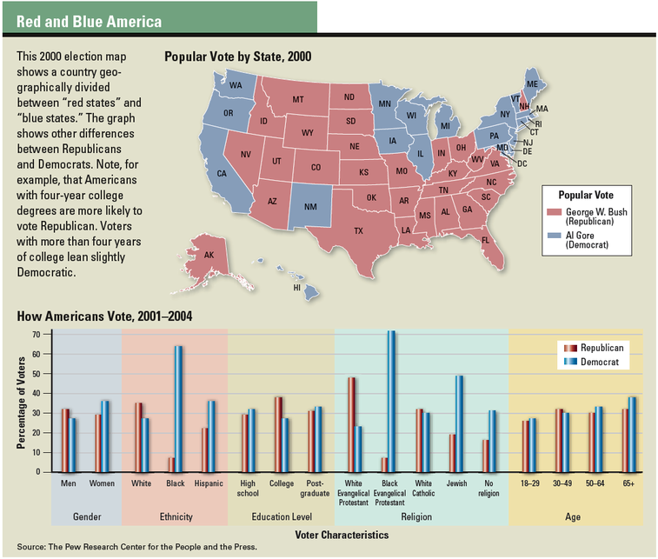

Republicans and Democrats in the Twenty-first Century
While all kinds of Americans support either party, a Republican is more likely to be white, male, and relatively affluent. A Democrat is more likely to be a member of a minority group, female, and less affluent. The graph on this page shows other differences between the Republicans and Democrats.
In general, Republicans hold more conservative views, and Democrats more liberal views, on the issues that follow.
Size of the national government. In general, Democrats support a strong federal government and look to it to solve a wide variety of problems. Most Republicans favor limiting the size of the national government and giving more power to the states to solve problems at a local level.
Taxes. Republicans favor broad-based tax cuts to encourage economic growth and to allow people to keep what they earn. Although Democrats favor tax cuts for the poor, they are more willing to raise taxes for affluent Americans in order to support programs that they see as beneficial to society.
Regulation of business. Democrats generally support government regulation of business as a way to protect consumers, workers, or the environment. Most Republicans oppose what they see as excessive business regulation by the government.
Social issues. Republicans tend to favor prayer in public schools, while opposing abortion and gun control laws. Democrats are more likely to support abortion rights and gun control laws, while opposing school prayer.
Minimum wage. Most Democrats favor regular increases in the minimum wage to support poor families. Republicans tend to oppose minimum wage laws as unnecessary economic regulation.
While these generalities hold for the two political parties, individual Democrats or Republicans may not share the same views on every issue. Republicans who call themselves Log Cabin Republicans, for example, strongly support equal rights for gay and lesbian Americans. At the same time, many traditional Republicans are just as strongly opposed to granting certain rights, such as the right to marry, to gay and lesbian couples.
Nevertheless, for most Americans, identifying with one party or the other provides a useful way to make sense of the candidates at election time. In effect, party labels tell voters what the candidates stand for and help them make choices when they vote.
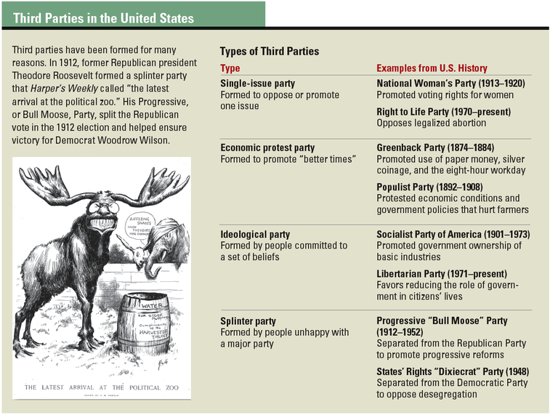
Culver Pictures/The Art Archive

Third Parties: Single-Issue, Economic Protest, Ideological, and Splinter Groups
Not all Americans identify with the two major parties. Throughout our country’s history, people frustrated with the status quo have formed third parties to express their opinions in constructive ways.
There are four main types of third parties in the United States. Single-issue parties tend to focus on one issue, such as taxes or immigration. Economic protest parties unite opponents of particular economic policies or conditions. Ideological parties view politics and society through the lens of a distinct ideology, such as socialism. And splinter parties develop as offshoots of the major parties. The table below lists an example of each type of third party.
Third parties have had some electoral successes. The Socialist Party gained a substantial following in the early 1900s. More recently, Reform Party candidate Jesse Ventura won election as governor of Minnesota in 1998. The Green Party has also enjoyed some success in elections, particularly at the local level.
Third parties have also advocated reforms that have eventually been adopted by the major parties. In the 1990s, for example, the Green Party helped raise awareness of environmental issues. Today “green” positions on the environment can be found in the platforms of the two main parties.
In general, however, third parties face an uphill battle given the strength of the two-party system. Smaller parties find it hard to raise money and get the media coverage they need to challenge the two major parties.

The Moderate Middle: Centrist and Independent Voters
In recent years, a growing number of Americans have declared themselves to be political independents. As such, they are not aligned with any political party. According to some political analysts, the rise of independent voters represents a turn away from the more liberal or conservative views of the two major parties toward a centrist, or middle-of-the-road, position.
Nevertheless, political scientists note that many people who embrace the “independent” label still tend to lean toward one or the other major party at election time. In other words, although these voters call themselves independent, they still vote like either Democrats or Republicans. The proportion of voters who are truly independent of either party has hovered around 10 percent since the 1950s.

Section 3 - Interest Groups in America
Americans join all kinds of groups that reflect their interests, from garden clubs and hiking groups to civic organizations. When such groups seek to influence government, at any level, they are called special-interest groups or special interests [special interest: a group that seeks to influence government policymaking and decision making to further its particular goals; an interest group] . The term special interest refers to a particular goal or set of goals that unites the members of a group. In the case of the National Rifle Association (NRA), for example, that goal is protecting the rights of gun owners. For the Wilderness Society, it is preserving wild lands.

Are Interest Groups Good or Bad for Democracy?
Many Americans distrust special interests. They believe that these groups seek to achieve their goals at the expense of society as a whole. According to this view, interest groups represent a selfish, corrupting force in U.S. politics. Is this a valid criticism or an unjust accusation?
More than two centuries ago, James Madison addressed this question in The Federalist Papers. In The Federalist #10, he wrote that “factions”—his term for interest groups—posed a threat to democratic government if their power went unchecked. At the same time, he believed that the growth of interest groups was inevitable, and even a good thing, in a society that prized freedom. The key issue was how to contain the threat while preserving liberty.
Madison believed that pluralism [pluralism: the idea that political power should be distributed and shared among various groups in a society] held the answer. Pluralism is the idea that political power should be distributed and shared among various groups in society. In theory, competition between these groups, along with an effective system of checks and balances, will prevent any one group from gaining too much power. According to Madison, interest groups competing in a pluralistic society should act as a check on tyranny and make government more representative.
Today, interest groups offer Americans a way to participate in the political process. Interest groups speak out on issues of concern to their members and the public at large. They present specialized information to government officials. They also monitor government actions to ensure that the rights and interests of their members are protected. In the process, interest groups help keep people informed about their government. Even though special interests occasionally influence the political system in negative ways, they play a critical role in the democratic process.
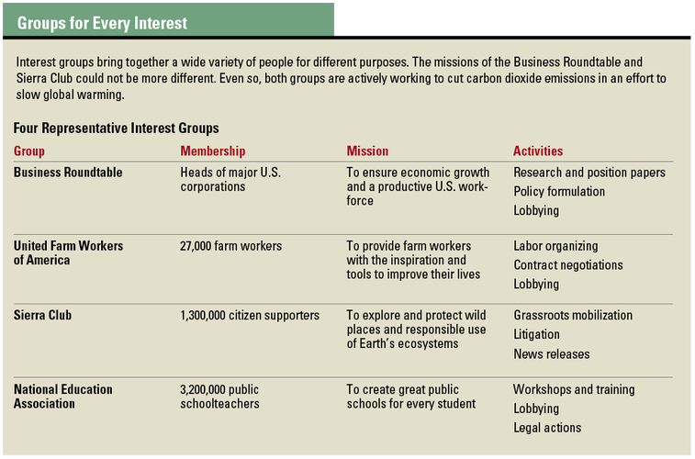

What Kinds of Interest Groups Do Americans Join?
There are thousands of interest groups in the United States. Although they differ in many respects, their basic goal is the same: they all try to persuade elected officials to take actions to support their interests. Special-interest groups fall into several categories, depending on their membership and goals. The table below highlights four such groups.
One of the largest categories consists of economic interest groups. This category includes business groups, trade organizations, professional associations, and labor unions. Examples include the Business Roundtable, the American Medical Association, and the United Farm Workers of America.
Another broad category consists of citizen groups, many of which claim to promote the public interest. Some of these groups may also be motivated by a particular ideology or set of issues. Environmental groups, such as the Sierra Club, belong in this category, as does the American Civil Liberties Union (ACLU). Some single-issue groups, such as Students Against Destructive Decisions (SADD), also fit in this category.
Government interest groups exist at every level of government. They include groups like the National Governors Association and groups that represent mayors or city managers. Public employee unions, like the National Education Association (NEA), also belong in this group.
There are other categories, as well, such as foreign policy interest groups, nationality groups, and religious organizations. At the same time, many special interests, such as the American Legion and the Veterans of Foreign Wars (VFW), do not fall neatly into any particular category. Nonetheless, such groups may be large and highly influential.

Why Do People Join Interest Groups?
Americans join interest groups for various reasons. Some join for the information and benefits the groups offer. Many interest groups publish newsletters and host workshops and conferences for members. Some offer training that helps members qualify for higher-paying jobs. AARP, formerly the American Association of Retired Persons, an interest group for older Americans, provides information on federal health insurance benefits and prescription drug programs. The American Automobile Association (AAA) offers benefits in the form of emergency towing service and discounts on insurance and travel.
Americans also join interest groups because they agree with the group’s goals and want to be part of a larger community of shared interests. The World Wildlife Fund (WWF), for example, attracts people who want to protect animal habitats. Members of the Christian Coalition of America share religious and political beliefs.
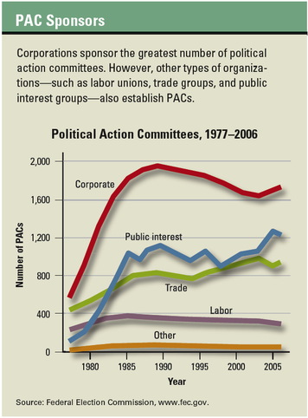

How Are Interest Groups Organized and Funded?
In an essay on democracy, policy analyst Archon Fung called “organized money and organized people” the sources of power in American politics. All interest groups need both money and people, but they are organized and financed in many ways.
Most interest groups have an elected board of directors or trustees who set policy and decide how the group’s resources will be used. Many groups have both national and state chapters, each led by their own boards or trustees.
Funding methods vary among interest groups. Many economic and single-issue groups get most of their operating expenses from dues, membership fees, and direct mail fundraising campaigns. Some public interest groups get their primary funding from foundations or government grants.

The Rise of Political Action Committees
One way that interest groups try to influence government is by contributing money to political parties and candidates during election campaigns. Campaign finance laws passed by Congress in the early 1970s placed limits on some types of campaign contributions. But these laws allowed the creation of new funding organizations called political action committees (PACs) [political action committees (PACs): an organization that raises and distributes funds to candidates running for office] .
PACs are private groups sponsored by corporations, trade associations, unions, or other interest groups. By law, PACs are allowed to collect donations and funnel that money into political campaigns. Most of these donations come from the employees or members of the group that formed the PAC.
Over the past decades, the amount of money raised and spent by PACs has grown. In 1980, PACs contributed about $131 million to candidates. By the 2004 election, that figure had risen to more than $310 million. Even adjusting for inflation, that is a substantial increase. Corporations are by far the top contributors to PACs, though many public interest groups, trade associations, and labor unions also make large donations.
Many Americans believe that PAC campaign contributions give interest groups too much influence over elected officials. Nevertheless, most research shows that PAC money does not buy votes in Congress. It does, however, give contributors greater access to lawmakers.

How Do Interest Groups Influence Policy?
Campaign contributions are one way interest groups try to influence government policy. But they have other, more powerful methods as well, such as lobbying [lobbying: an organized effort to influence the policy process by persuading public officials to favor or oppose action on a specific issue] , research, litigation, and grassroots mobilization.
Lobbying. Many interest groups rely heavily on lobbying to advance their interests. Lobbying is an attempt to influence the policy process by persuading public officials to favor or oppose action on a specific issue. Lobbyists speak to members of Congress and their staffs, testify before congressional committees, and offer comments at hearings held by executive agencies. Often they provide useful information that helps officials create policies that serve the public interest.
Senator Edward Kennedy of Massachusetts has noted that lobbyists play a useful role in the political process. “Without lobbying, government could not function,” he said. “The flow of information [from lobbyists] to Congress and to every federal agency is a vital part of our democratic system.”
Research and policy proposals. Some interest groups carry out research and write policy proposals that support their goals. In some cases, they work with think tanks [think tank: an organization of scholars and policy experts who study public issues and write articles and books summarizing their research] to carry out this research. A think tank is an organization of scholars and policy experts who study public issues and write articles and books that summarize their research. Interest groups use these expert findings to influence government officials.
Litigation. Interest groups may also try litigation [litigation: the process of bringing a lawsuit against someone] , or the bringing of lawsuits, to influence policy. One interest group that has used litigation effectively is the National Association for the Advancement of Colored People. Lawyers for the NAACP have brought numerous lawsuits to court to advance the cause of civil rights. The NAACP’s most famous victory came in the 1954 Supreme Court case of Brown v. Board of Education, which helped bring an end to segregation in public schools.
Grassroots mobilization. Another way interest groups try to influence policy is through grassroots mobilization [grassroots mobilization: the rallying of strong and vocal support from a large group of people at the local level] . Basically, this means rallying strong and vocal support from a large group of people at the local level.
Grassroots mobilization often takes the form of public demonstrations, such as antiwar protests or antiabortion rallies. Increasingly, however, it is carried out by mail or over the Internet. Interest groups call on members to write cards or flood the e-mail inboxes of public officials with messages urging a particular course of action.

What Makes an Interest Group Powerful?
Several factors help interest groups become successful. Size and money are key factors, but other criteria can also play a role.
Size and money. Interest groups often succeed when they have a large membership and substantial resources. Interest groups with millions of members can gain the attention of government officials through sheer force of numbers. With ample funds, they can afford to maintain offices around the country, hire a large staff, and pay travel and lobbying expenses. They can also produce expensive media ads to raise their public profile.
Unity of purpose. Size and resources matter, but so does the commitment of members to the group’s goals. Small, single-issue, or ideological groups may demonstrate this unity most effectively, because their members tend to be motivated and focused. But even a large, diverse group like AARP can show great unity of purpose. When the members of an interest group voice unified, forceful views on an issue, government leaders tend to listen.
Effective leadership. Strong leadership is another critical factor in an interest group’s success. Effective leaders can clearly express the group’s message and win support from others. Without effective leadership, even a group with a powerful message may fail to achieve its goals.
Information and expertise. Successful interest groups know how to gather and analyze information and deliver it to decision makers. For example, in the 1970s, Ralph Nader’s interest group Public Citizen used careful research and analysis to convince Congress to pass consumer protection laws that improved car safety.
Not surprisingly, large, well-funded groups have a clear advantage in efforts to influence government policy. Nevertheless, many small but dedicated interest groups have also had a notable impact, despite their limited resources.

Section 4 - Making Public Policy
For decades, U.S. officials have considered ways to reduce the nation’s dependence on foreign oil as part of a broad-based energy policy. Should the government permit oil drilling in waters off the nation’s coasts? Should drilling be allowed in national parks and wildlife refuges? Should public money be used to develop other energy sources, such as solar, wind, and nuclear power? The answers to such questions have shaped our nation’s public policy [public policy: a plan or course of action initiated by government to achieve a stated goal] on energy.
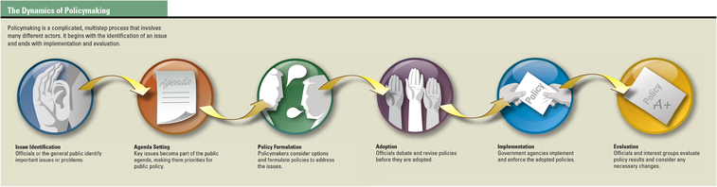
Public policy refers to government actions or programs designed to achieve certain goals. Creating public policy is a multistep process. Government officials, policy experts, political parties, interest groups, and concerned citizens all take part in such policymaking. The diagram below outlines how the policymaking process works.

Seeing What Needs Attention: Issue Identification
The first step in policymaking is identifying problems and issues that need to be addressed. Sometimes a crisis brings an issue to public attention. This happened when Middle East oil producers blocked sales to the United States for a few months in 1973 and 1974. The resulting energy crisis forced Americans to begin thinking of ways to reduce this nation’s dependence on foreign oil.
Public officials can also raise awareness of issues. Until 1964, for instance, most Americans viewed smoking as a matter of personal choice. That year, the surgeon general of the United States issued a report linking cigarette smoking to lung cancer. His report raised the issue of whether smoking should be discouraged as a matter of public policy.

Choosing Issues to Address: Agenda Setting
Government officials cannot address all the problems facing the nation at any one time. They have to make choices, selecting the issues that seem most critical and setting others aside. Agenda setting requires officials to decide which issues should be part of the public agenda [public agenda: a set of priorities for public action] , or set of public priorities.
Some issues pop onto the public agenda as a result of a disaster. The 9/11 terrorist attacks on the World Trade Center and the Pentagon put fighting terrorism high on the nation’s public agenda. Similarly, after Hurricane Katrina devastated New Orleans in 2005, repairing damaged levees around the city shot to the top of that area’s public agenda.
Other issues take a long time to become part of the public agenda. One example is global warming. For years, scientists have been warning about the effects of greenhouse gas emissions on Earth’s climate. But for the most part, their concerns were ignored. As scientific knowledge and evidence of climate change have mounted, however, global warming has found its way onto the public agenda of many public officials and lawmakers.
Political parties and interest groups often play a role in setting the public agenda. Parties help by placing issues on their platforms, thus making those items a priority for the candidates they elect. Interest groups do the same by lobbying for certain issues.

Deciding What to Do: Policy Formulation
Once an issue is on the public agenda, government officials work on formulating a policy to address it. This step may take place within any branch of government. It can also happen at the local, state, or national level. Legislatures or city councils make policy by passing laws or statutes. Executive officials or agencies make policy by setting new rules and regulations. The judicial system can influence policy, too, through court decisions and rulings.
When officials begin to formulate a policy, they ask some basic questions: Is this a problem government should address? If so, what options should be considered? Should government pass a new law, create a new or expanded program, or offer a new benefit? What are the costs and benefits of each option?
In response to the surgeon general’s report on smoking, for example, officials considered a number of policies. These ranged from warning labels on cigarette packages to regulating cigarettes as drugs. When considering such varied options, officials may ask experts to offer their opinions. They may also invite interest groups to present their views. This helps ensure that the policy they finally adopt takes various perspectives and interests into account.

Putting Proposals into Action: Policy Adoption
Many policies are formulated as legislation. These bills must first pass through Congress, state legislatures, or city councils to become law. This legislative process often results in substantial revisions. A policy proposal may be changed to gain the support of a majority of legislators. Or it may be modified to avoid legal challenges or a threatened veto by a governor or president.
Sometimes the president works with members of Congress and key interest groups to get policies adopted. President Lyndon Johnson, for instance, worked closely with Congress and civil rights leaders to win passage of the landmark Civil Rights Act of 1964. In 1990, President George H. W. Bush joined with lawmakers and disability activists to pass the Americans with Disabilities Act. This law helped make public facilities more accessible to people with disabilities.
In other cases, interest groups take the lead in getting new policies adopted. The American Cancer Society and the American Lung Association, for example, have taken the lead in promoting laws banning smoking in public places. By 2007, a number of state and local governments had been convinced to enact laws creating smoke-free restaurants, hospitals, and workplaces.

Making a Policy Work: Implementation
After a policy is adopted, it must be implemented. Usually, implementation is assigned to a specific government agency. That agency then becomes responsible for making the new policy work.
After the 9/11 terrorist attacks, for example, Congress enacted a number of antiterrorism policies. The job of implementing these policies was given to the newly created Department of Homeland Security. DHS took on a host of responsibilities, from intelligence gathering to border security. To accomplish its goals, DHS officials worked closely with state and local governments.

Assessing the Effectiveness of a Policy: Evaluation
The final step in the policy process is evaluation. Government officials and concerned interest groups assess whether implemented policies have met their goals. If changes need to be made, the policymaking process begins again.
After New York City outlawed smoking in bars and restaurants in 2003, the city’s Department of Health carried out a study to assess the results. Its researchers found that air pollution levels had decreased sixfold in bars and restaurants after the ban went into effect. The study also found that contrary to predictions, business remained good despite the smoking ban. A 2006 study by the state of New York found similar results.
Not all policies that show positive results manage to survive, however. For example, studies show that a policy of requiring motorcycle riders to wear helmets reduces the likelihood of dying in a crash by about one-third. Nonetheless, faced with stiff opposition from motorcycle riders, some states have not passed mandatory helmet laws. Moreover, a few states with such laws have repealed or are considering repealing them. For a policy like this one to be successful, it must achieve its goals and win public approval.

Summary
Political parties and interest groups play an important part in American politics. They exert a strong influence on government and offer ways for Americans to participate in the political process.
Political parties Political parties perform various functions. They run candidates in elections and help inform voters about political issues. They also organize the government. The United States has a two-party system, dominated by the Democratic and Republican parties. Nonetheless, third parties and independent voters have an impact on elections and issues as well.
Interest groups Many Americans distrust interest groups. Nevertheless, these groups play a vital role in our political system. Interest groups provide information that helps public officials do their jobs. They also help inform Americans about the actions of their government.
Public policy The creation of public policy is a multistep process. It begins with the identification of issues. If an issue is considered important, it becomes part of the public agenda. Officials then address the issue by formulating a policy. After the policy is adopted and implemented, officials and other interested parties evaluate its results. If the policy has failed to meet its goals, the process may begin all over again.

