Lesson 2 - Comparing Forms of Government

Section 1 - Introduction
In September 2012, delegates representing the 193 members of the United Nations met in New York City for the 67th session of the UN General Assembly. The majority of these nations' governments are categorizes as democracies. The governments of a few nations are monarchies. Fewer yet are dictatorships.

Among the members of the United Nations are countries with vastly different populations, forms of government, and economic systems. Consider, for example, the differences between two of the newest members: Switzerland and South Sudan. Switzerland joined the United Nations in 2002, and South Sudan joined in 2011. However, other than UN membership, Switzerland and South Sudan have little in common.

Switzerland existed as an independent nation in Central Europe for more than 350 years before joining the United Nations. Seven million Swiss live in a prosperous nation with a thriving market economy. With a literacy rate of 99 percent, the Swiss are among the world’s best-educated people. They also enjoy one of the world’s highest standards of living.

In contrast, South Sudan became an independent state several days before joining the United Nations in 2011. Prior to its independence, South Sudan was a part of Sudan, a landlocked African country with a history of political instability and civil wars. Since Sudan gained independence from British rule in 1956, the people of southern Sudan sparsely won positions in their government. After years of war and discontent, South Sudan finally gained independence. Today, South Sudan is an impoverished nation with a traditional economy. About a quarter of adults in South Sudan can read, and living standards are low.

The people of Switzerland and South Sudan do have one thing in common. When facing the question of who should have power to rule their nations, both answered, “the people.” For the Swiss, this decision was made in 1848, when they adopted a constitution that created a democratic government. The South Sudanese, however, only recently decided to build a democracy. Whether this endeavor will be successful in this trouble country remains to be seen.

Section 2 - The Origins and Evolution of Government

All societies, large and small, develop some form of government. During prehistoric times, when small bands of hunter-gatherers wandered Earth in search of food and game, government might have been as simple as a few elders making decisions for the group. The invention of farming triggered the evolution of more formal systems of governments. Once people learned how to raise food, they settled down into permanent villages. This new way of life created a host of novel problems and conflicts. Governments had to evolve to meet the needs of the more complex societies they ruled.

The Ancient World: From City-States to Empires
Over time, some farming villages grew into cities and city-states. A city-state is a sovereign state consisting of a city and its surrounding territory.
Around 3000 B.C.E., the first city-states arose in Sumer, a region located in what is today southern Iraq. There, between the Tigris and Euphrates rivers, the Sumerians grew crops of barley, wheat, dates, apples, and plums.

Then, as now, the land between the Tigris and Euphrates was largely desert. Farming in this region depended on irrigation. Governments arose to resolve issues pertaining to the fair and orderly distribution of water. They also provided protection by building walls around their cities and organizing armies to ward off invasions by nomadic tribes. A similar evolution occurred in ancient Egypt, India, and China.

Gradually, power in many city-states became concentrated in the hands of a single ruler. The strongest of these rulers conquered neighboring city-states to create the world’s first empires. Sargon of Akkad was one of Sumer’s early conquerors. Sargon, whose name is thought to mean “the true king,” carried out more than 30 battles against the Sumerian city-states to consolidate his empire. To legitimize their power, empire-builders like Sargon often declared that the gods had given them the right to rule. Some rulers even claimed to be gods themselves. As power passed from father to son in these early empires, monarchy became the most common form of government in the ancient world.

Greece and Rome: Early Forms of People Power
In the fifth century B.C.E., the Greek city-state of Athens made a radical change in its form of government. The Athenians reorganized their city-state as a direct democracy. In a direct democracy, public decisions are made directly by citizens meeting together in an assembly or voting by ballot. The Athenian leader Pericles explained the new form of government this way:

Our constitution is called a democracy because power is in the hands not of a minority but of the whole people. When it is a question of settling private disputes, everyone is equal before the law; when it is a question of putting one person before another in positions of public responsibility, what counts is not membership of a particular class, but the actual ability which the man possesses.
—Pericles, Funeral Oration, 431 B.C.E.

When Pericles spoke of government being in the hands of “the whole people,” he meant in the hands of male citizens of Athens. Women, slaves, and foreign-born people living in Athens were not allowed to participate in government affairs. For those who did qualify, however, they participated on a scale that was unique in the ancient world. Never before had so many people dedicated so much of their time to the business of governing themselves.

Elsewhere, the Italian city-state of Rome was developing a different form of people power. In 509 B.C.E., the Roman people overthrew their monarchy and turned Rome into a republic. Over time, the Romans set up a representative democracy to govern their republic. In a representative democracy, public decisions are made by leaders who are elected by the citizens to represent their interests.

The Roman Republic lasted nearly 500 years. During that time, officials elected by Rome’s citizens headed the government. Then, in 31 B.C.E., after 20 years of civil war, the Roman Empire was established. Power passed from elected leaders to emperors who held absolute power for life.

The Middle Ages: From Feudalism to Nation-States
For a time, Rome’s emperors ruled an empire that included most of Europe, as well as North Africa and western Asia. In 476 C.E., Rome fell to invading tribes from the east. In parts of Europe once ruled by mighty Rome, the empire broke into tiny districts, each ruled by a duke, lord, king, or other noble.

With no strong central government to provide security, each district had to look out for itself. It often made sense for weak nobles to look to a nearby, more powerful neighbor for protection. However, protection had a price. Because money was scarce, the powerful lord or local king usually took his payment in land. In this way, some lords gained control of very large areas.

By the 700s, many lords acquired more land than they could manage. They began granting parcels of land, called fiefs, to tenants. In return, the tenant became the lord’s vassal. A vassal took an oath of loyalty to the lord and promised to provide him with military service in time of war. This system of exchanging the use of land for military and other services became known as feudalism.

In addition to serving as warriors, the vassals also had political obligations. For example, they all sat together at the lord’s court to help settle disputes. The lord was also expected to seek the advice and consent of his vassals before making new laws. Europe’s parliaments developed from meetings of vassals summoned by a lord or king.

During the 1200s, the feudal system of lords and vassals entered a period of decline. The 1300s saw the rise of absolute monarchies, or governments headed by hereditary rulers who claimed unlimited powers. These powerful monarchs consolidated the patchwork of feudal districts in their kingdoms into the world’s first nation-states.

By the 1700s, several European countries had become nation-states headed by absolute monarchs. These all-powerful rulers based their legitimacy on the divine right of kings theory. So important was the role of the monarch in France that Louis XIV is reported to have said of himself, “L’état c’est moi” (“I am the state”).

The Age of Revolutions: Democracies and Dictatorships
Some monarchs ruled with the best interests of their people in mind. Others ruled as despots, or tyrants, who used their power for selfish ends.Growing dissatisfaction with this form of government triggered a series of world-altering revolutions, first in Europe and then in the American colonies.

The first of these revolutions against tyranny occurred in England in 1688. The Glorious Revolution, also known as the Bloodless Revolution, led to the establishment of Europe’s first constitutional monarchy—a system of government in which the powers of the monarch are limited by a constitution, either written or unwritten.

The second of these revolutions began in 1775 when American colonists rebelled against what they saw as British tyranny. The American Revolution led to the creation of the first modern constitutional democracy—a democratic government based on a written constitution. Abraham Lincoln would later describe this form of democracy as “government of the people, by the people, for the people.”

A third revolution broke out in 1789, when the French people took up arms against their king. At first the French Revolution seemed likely to produce another constitutional democracy. Instead it took a radical turn and eventually collapsed into chaos. In time Napoleon Bonaparte restored order, but only by establishing an authoritarian regime—a system of government in which the state exercises broad control over the lives of its citizens. Napoleon, for example, used secret police forces to spy on French citizens. To stifle opposition, he censored the press while mounting his own propaganda campaigns.

Some historians argue that Napoleon’s approach to governing set the stage for rise of totalitarianism in the 20th century. A totalitarian government is an extreme form of an authoritarian regime that seeks to control almost every aspect of its citizens’ lives.

Twentieth-century totalitarianism dates back to the Russian Revolution of 1917. That revolution overthrew the Russian monarchy. In its place, revolutionaries established the Soviet Union as the world’s first state based on communism.
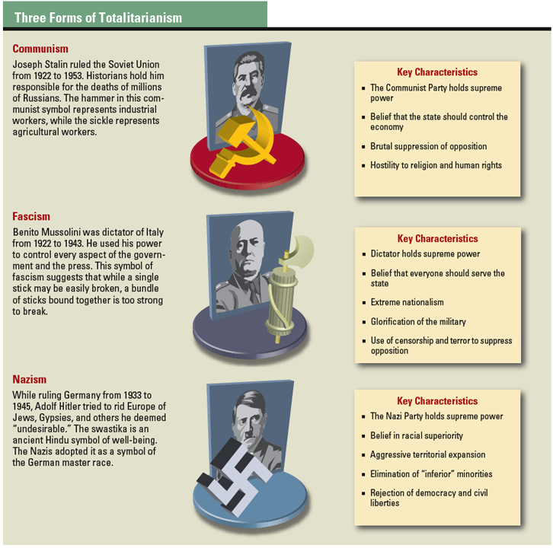
The term communism has several meanings. It can mean a system of government in which a single political party controls the government and the economy. It can also mean the theories developed by German philosopher Karl Marx about the ideal society. Marx’s goal was the creation of a society that provides equality and economic security for all. To accomplish that end, he called for government ownership of land, factories, and other resources.

The theory of communism appealed to many people in the 1900s. In practice, however, it led to the creation of totalitarian states, first in the Soviet Union and later in other countries, such as China, Vietnam, and Cuba. In these states, dictators like Joseph Stalin used spies, secret police, and government censors to suppress all opposition.

A form of totalitarianism known as fascism first appeared in Italy during the 1920s. Fascism resembles communism in terms of its control of citizens’ lives. Unlike communism, however, fascism allows businesses to remain in private ownership, though under government control. Benito Mussolini, the fascist dictator of Italy, used his power to turn his country into a police state.

A third type of totalitarianism, Nazism, took root in Germany. Nazism is a variety of fascism built in part on the myth of racial superiority. After taking power in Germany in 1933, Nazi leader Adolf Hitler launched an extermination campaign against Jews, Gypsies, and other groups he defined as “undesirable.”

Section 3 - Forms of Government in Today's World
With the exception of Antarctica, the landmasses on Earth are divided into nation-states. Some of these countries, such as Switzerland, have existed for hundreds of years. Others, like South Sudan, are new. Almost all have some form of functioning government. As Aristotle observed more than 2,000 years ago, these governments fall into three broad groups: rule by the one (monarchies and dictatorships), rule by the few (theocracies and single-party states), and rule by the many (parliamentary and presidential democracies).

Monarchy: Rule by the One Hereditary Ruler
Monarchies are one of the oldest forms of government still found in the world today. For monarchal government to have survived for thousands of years, it must have enduring attractions.

One of those attractions is efficiency. Traditionally, a ruling monarch has been able to make decisions and have them carried out on his or her word alone. As a result, new policies can be carried out without a lot of political bickering. A second advantage is a clear line of succession. Citizens living in a monarchy know who is next in line for the throne. A third is the unifying power of monarchy. Loyalty to a ruling family can be a strong bond holding a nation together.

At the same time, monarchal government has its drawbacks. One is the varying quality of hereditary leaders. An exemplary monarch in one generation may be followed by an incompetent one in the next. Also, the job of running a modern nation-state has become too big for any but the most exceptional monarchs to do well.

Today’s monarchs go by many names, including king, queen, sultan, emperor, and amir. Most have inherited their power and expect to rule for life. But the modern monarch’s power is rarely as great as in the days of Louis XIV and other absolute monarchs.

Most monarchs today face rigid legal restrictions on their power, often imposed by a constitution. The British monarch, for example, has the formal authority to call elections and appoint a new prime minister. These functions, however, are strictly ceremonial. Real power rests with Great Britain’s democratically elected leaders.

In contrast, Saudi Arabia’s king exercises broad powers. He inherits his position and has legislative, executive, and judicial powers. There are no recognized political parties or national elections in Saudi Arabia. The king may seek support from the royal family, religious leaders, and other important members of Saudi society. However, in theory, only Islamic law and Saudi traditions limit his powers.

In 2011, a series of uprisings known as the Arab Spring challenged monarchies in Southwest Asian countries. Several protests erupted in Saudi Arabia, but King Abdullah maintained his power.

Dictatorships: Rule by the One Powerful Leader
Whereas monarchs inherit their power, dictators take and hold power by force. Muammar al-Gaddafi, for example, took control of Libya in a military coup d’etat, or coup, in 1969. The term coup d’etat means “blow to the state” in French. A coup is the sudden overthrow of a government by a small group of military officers or political leaders. This often happens during a time of political unrest or a national emergency.

Dictatorships share some of the advantages of absolute monarchies. Power is centralized in the hands of a single military or political leader who can get things done efficiently. With control of the military and police, the leader can put an end to political unrest and maintain peace and order. That same power, however, can easily be used to abuse citizens who oppose the dictator’s authoritarian regime.

Dictatorships face serious legitimacy problems. Over time, pressure often builds to return the government to control by elected leaders. When this happens, ruling becomes increasingly difficult. For example, in February 2011, growing discontent led to a wave of protests in Libya, calling for an end to Gaddafi's rule. Months later, he was overthrown.

Theocracy: Rule by the Few Religious Leaders
A theocracy is a government headed by religious leaders. In ancient city-states, theocracies were common, with government officials serving as religious leaders as well. Having a government based on one set of religious beliefs had clear benefits. A single, state-supported religion encouraged political and social unity. It also ensured that political decisions were in line with the people’s moral values and beliefs.

As states grew larger, however, enforcing religious unity became increasingly difficult. Religious minorities were often marginalized or even persecuted. Religious warfare broke out as groups with differing beliefs fought for control of their governments.

By 2007, only two theocracies existed in the world: Vatican City and Iran. Vatican City is the governmental and spiritual center of the Catholic Church. Although located in the heart of Rome, Italy, it is an independent state headed by the Catholic pope.

Iran changed from a monarchy to a theocracy in 1979. That year, Iranians expelled their hereditary ruler and formed an Islamic republic headed by a religious leader known as the Ayatollah Khomeini. As Iran’s supreme leader, the Ayatollah put into practice his belief that “in Islam, the legislative power and competence to establish laws belong exclusively to God Almighty.” The most influential body in Iran’s theocracy is the 12-person Council of Guardians. Their job is to make sure that the laws of the country conform to Islamic religious law.

Single-Party State: Rule by the Political Elite
In a single-party state, the constitution allows only one political party to govern. Power is exercised by the leading members of the party, who form the nation’s political elite, or a small group of people within a larger group who have more power, wealth, or talent than the others. The party elite nominate candidates for public office and make most policy decisions for the country.

Ideally, a single-party system avoids much of the political wrangling that is common in multiparty states, making it easier to pass laws and implement government policies. This party unity comes at a cost, however. The views of the party elite may be very different from the interests of the people as a whole, leading to social unrest. Also, people with differing political views or solutions to problems are often completely shut out of the political process.

The handful of single-party states today are mainly socialist republics, in which the Communist Party rules. In Vietnam, for example, the Communist Party is the only legal political party. Syria is an example of a non-communist single-party state. It is dominated by the Ba’ath Party, which supports Arab nationalism and unity.

Direct Democracy: Rule by All Citizens
In the direct democracy of ancient Athens, several thousand citizens met regularly as an assembly to make decisions for their city-state. Each citizen had an equal voice in public affairs, and decisions, once made, had widespread support. Nonetheless, this form of government was time-consuming for citizens. That may be one reason why Athenian-style democracy was not widely copied in the ancient world.

In the modern world, no country is governed as a pure direct democracy. The country that comes closest is Switzerland. Swiss citizens regularly vote to approve laws passed by their legislature. This form of direct democracy is known as the referendum process. Citizens may also propose laws and submit them directly to voters in what is known as the initiative process. As much as the Swiss value their form of democracy, voter turnout is often low, because people tire of frequent elections.

Limited forms of direct democracy exist in the United States. One is the New England town meeting, where townspeople meet to discuss and solve local problems. In several states, voters help shape public policy through the initiative and referendum processes. They may also be able to vote an elected official out of office by means of a recall election. In 2012, the governor of Wisconsin, Scott Walker, faced a recall election. However, the recall failed, and he retained his position.
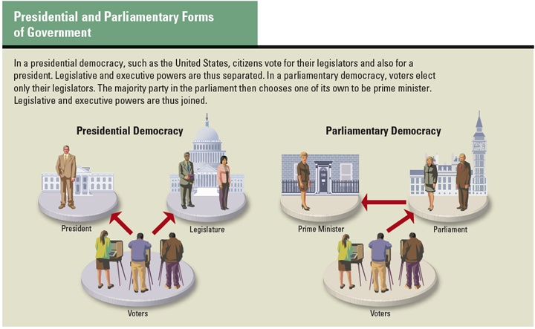

Parliamentary Democracy: Rule by a Legislative Majority
Most nations today have adopted one of two forms of representative democracy: parliamentary or presidential. Both forms use elections to choose national leaders. But they differ in other ways.

The United Kingdom, India, and Australia are examples of parliamentary democracies. In a parliamentary democracy, voters elect lawmakers to represent them in the nation’s parliament. The party that wins a legislative majority forms a new administration. If no single party wins a majority, several parties join together to form a ruling coalition.

The legislative majority then selects a member of parliament to serve as the nation’s prime minister, or chief executive. Usually the person chosen is the leader of the party with the most seats. The prime minister then chooses other members of parliament to head key government ministries, or executive branch departments.

In a parliamentary democracy, there is no clear-cut separation between the executive and legislative branches of government. Members of the legislative majority usually vote with the prime minister on key issues. This may make it easier to get legislation passed than in a presidential system. However, the lack of separation means there is no real check on the prime minister’s power. Also, the prime minister may lack the legitimacy and public support of an elected president.

Prime ministers remain in power only so long as they have the support of parliament. Should parliament approve a vote of no confidence, the prime minister must resign. At that point, an election may be held to choose a new legislative majority. Although forcing an unpopular prime minister out of office in this way may seem democratic, it can also make parliamentary governments unstable.

Presidential Democracy: Rule by Representatives of the People
The United States, Russia, and most countries in Latin America are presidential democracies. Voters in these countries choose a president to lead the government as the head of the executive branch. They also elect lawmakers to represent them in a national legislature. Both the president and the legislators serve fixed terms of office.
This system has some advantages over a parliamentary democracy. Because presidents are directly elected by the people, they may be more responsive to the public than to their party. They may also enjoy more legitimacy and public support than does a prime minister chosen by a parliament. The presidential system also separates executive and legislative powers, which allows each branch to watch over the other to prevent abuses of power. Also, with fixed terms, a presidential system may be more stable than one in which the prime minister can be dismissed at any time.

This system does have several disadvantages when compared with a parliamentary one. First, it is almost impossible to remove presidents from power before their terms end, no matter how unpopular they might be. Also, when presidents are not from the political party that controls the legislature, the result can be gridlock—a situation in which little or no progress is made on pressing issues. Finally, in some countries, presidents have used their power to establish authoritarian regimes.

Section 4 - The Distribution of Power in Governments Today

In almost all nation-states, government power is exercised at a minimum of two levels: national and regional. In the United States, each region is called a state. In other countries, regions have names such as canton, province, prefecture, land, and département. Just how power is distributed between these two levels depends on which system of government a country has: unitary, federal, or confederal.

Unitary Systems Centralize Power
In a unitary system of government, the constitution concentrates power in the national, or central, government. The national government may choose to create regional governments to carry out its policies. However, regional governments exercise only those powers given to them by the national government. The national government may also appoint the officials who run the regional governments.

Most nation-states have unitary systems. The main advantage of this system is that it promotes national unity by having all parts of a country follow the same laws and policies. However, most unitary nations have discovered that too much centralization is not good in practice. Policies that fit one region of the country may not work as well in another. Also, officials working at the national level cannot know the needs of every town and village. As a result, most unitary states have decentralized to a certain degree, allowing regions some powers of their own.

In Japan, for example, the central government has the constitutional power to control its 47 regions, which are called prefectures. It makes national laws that the regional governments must carry out. It also provides funds without which the prefectures could not operate. Yet the prefectures—along with Japan’s cities, towns, and villages—have a significant amount of control over local affairs.

Federal Systems Divide Power
In a federal system of government, the constitution divides power between the national government and the regional governments. The national government has some fixed responsibilities, such as protecting the nation. The regional government has other responsibilities, such as setting up schools.

A federal system of government is most likely to be adopted in large countries with diverse populations. The main advantage of such a system is the flexibility it gives regional governments in meeting the needs of different language and ethnic groups. The downside of this flexibility can be a patchwork of competing laws from region to region. In addition, conflicts may arise between the central government and regional governments.

India, whose people speak more than 1,000 languages and dialects, adopted a federal system after gaining independence in 1947. Its constitution clearly specifies how powers are to be divided between the national government and the 28 Indian states.

Confederal Systems Decentralize Power
The United States was the first modern country to adopt a federal system of government. However, it did not always have a federal system. The first American constitution, the Articles of Confederation, created a confederal system of government. In such a system, power resides in the regions, which are independent states. The regions grant only as much power to the national government as needed to maintain security and to coordinate activities among the regions.

The American states first chose a confederal system because it offered two important advantages. It allowed the states to unite for some purposes without giving up the power to run their own affairs. This allowed for greater flexibility in meeting local needs. And, by limiting the powers of the central government, a confederal system reduced the likelihood that it would become an authoritarian regime.

Within a few years, however, the states reconsidered their choice. The central government, they realized, was too weak to meet the needs of the nation as a whole. It also lacked the power to end quarreling among the states. The result was an unworkable system that threatened the very survival of the nation.

No nation-state is organized as a confederation today. However, some supranational organizations, such as the European Union (EU), are modeled on confederal systems. The member nations of the EU give some power to the EU government, such as control over cross-border trade. But they remain sovereign nations and can leave the EU at any time. Thus far, its members have found the benefits of union worth the cost of sharing some power with the EU.

Section 5 - Economic Systems Around the World

Just as forms of government vary from one nation to the next, so do economic systems. An economic system is a way of organizing the production and consumption of goods and services. Economic systems exist because people must meet certain needs to survive. These survival needs include food, clothing, and shelter. In addition, people have endless wants. Such wants may include things that make life more comfortable, more entertaining, or more satisfying in some way.

Three Fundamental Economic Questions: What to Produce, How, and for Whom?
If a nation’s resources were unlimited, it might be possible to meet all of these wants and needs. But such is never the case. Resources are always limited. As a result, every economic system must answer three fundamental economic questions:
What goods and services should be produced? For example, should a nation’s limited resources be used mainly to provide public goods, such as clean air and water, or to produce private goods, such as homes?

How should these goods and services be produced? Should corn and wheat be raised mainly on giant factory farms? Or is farming better done on smaller family farms?

How should the people share goods and services? Who should get what? Only those who can afford whatever they want? Or should goods and services go to the people who need them the most?

Economic systems differ from one country to another because each society answers these questions in its own way.

The Four Factors of Production: Land, Labor, Capital, and Entrepreneurship
Countries also differ in how they use what economists call the factors of production. These factors are the resources required to produce most goods and services. They include the following:

Land. By land, economists mean the natural resources of a nation. These raw materials include fertile soil, water, plants, and minerals.

Labor. Labor refers to the effort—both mental and physical—that people put into producing goods and services.
Capital. The term capital has multiple meanings. It can mean the money needed to start a business. It can mean the machinery, buildings, tools, and equipment used to produce goods and services. It can also mean human capital—the knowledge and skills that workers bring to their jobs.

Entrepreneurship. This last factor is the human effort that goes into organizing land, labor, and capital to produce and sell goods and services. Entrepreneurs risk their money and time to turn an idea into something that people will want or need.

The way a society uses these factors of production is determined by its economic system. Three basic types of economic systems exist in the world today: traditional, market, and command.

Traditional Economies: Decision Making by Custom
In a society with a traditional economy, people rely on time-tested customs to answer the three fundamental economic questions. What worked for their ancestors still works today.

People in traditional economies provide for themselves. Some are hunters and gatherers, as they have been for thousands of years. The majority are farmers. Most people in a traditional economy live at a subsistence level, producing just enough goods to feed, clothe, and house their families. If they have any goods left over, they trade them for other things they need or want.

Many of the Inuit of Alaska and northern Canada still maintain a traditional economy based on hunting and fishing. They rely on skills and strategies that have helped their people survive since prehistoric times. Likewise, many African farmers and herders follow the same economic patterns as their ancestors.

In a traditional society, the production and distribution of food, clothing, and shelter is woven into the fabric of society. Economic activities do not need to be coordinated or regulated in any way by the government. Tradition and community values serve to keep the economy running smoothly. However, the standard of living of most people in traditional economies is very low. Families do not earn enough to do more than meet their most basic needs. They have only limited access to goods such as cars or services like medical care.

Market Economies: Decision Making by Individuals
In a country with a market economy, individual producers and consumers answer the three basic economic questions. In a pure free-market economy, the government plays little or no role in economic affairs. Producers are free to decide what goods and services to produce and how much to charge for them. Consumers are free to decide what to buy. Prices are determined by the market. In economic terms, a market is any place or situation in which people buy and sell goods and services.

You have probably heard other names for a market economy. Some people refer to it as a free enterprise system. A free enterprise system relies on the profit motive, economic competition, and the forces of supply and demand to direct the production and distribution of goods and services.

Others use the term capitalism to describe a market system. Under capitalism, individual investors, or capitalists, privately own the means of production, such as farmland or factories. Workers provide labor in exchange for wages or a salary.

One advantage of a market system is its efficiency at meeting peoples’ needs. When demand for a product rises, its price in the market goes up. This signals businesses to produce more. Meanwhile, competition among producers of similar goods usually keeps prices from rising too high. Efficiency also leads to economic growth. Businesses invest in factories and equipment, as well as in research and technology, to stay competitive. This helps the economy grow.

One disadvantage of a market economy, some would argue, is its instability. Periods of growth and prosperity in market economies usually alternate with recessions, or slow-downs, in business and employment. During these downturns, people who lose their jobs suffer from a loss of income.

Another disadvantage of a market economy is its unequal distribution of wealth. The market divides wealth to people according to how society values what they do. For example, a quarterback whose team wins the Superbowl earns more than a public school teacher. This may seem unfair, but there are more teachers than Superbowl-winning quarterbacks.
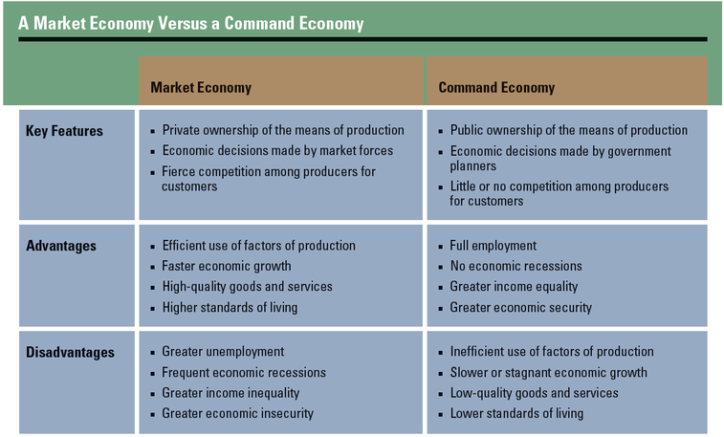

Command Economies: Decision Making by Government Planners
In a command economy, the government answers the three basic economic questions. In a pure command economy, the means of production are publicly owned. Government planners decide what goods and services should be produced and how. They also determine how goods and services should be distributed to consumers and at what cost.

Command economies are based on political theories that arose in Europe during the late 1800s. Known both as socialism and communism, these theories addressed the inequalities of capitalism by calling for public ownership of farms and factories. Once the people controlled the means of production, the economy could be operated on such principles as equality and fairness to all. Karl Marx, the originator of communism, summed up how such an economy would work in this slogan: “From each according to his ability, to each according to his needs.”

In theory, a command economy has distinct advantages over a market economy. Central planners can ensure full employment by devising enough projects to absorb all members of the workforce. This ability, along with controls on prices, can bring stability to the economy. A command economy can also distribute income more equally than a market economy, because everyone shares in the nation’s wealth.

In practice, however, the performance of command economies has been disappointing. Because the government controls wages and prices, workers have little incentive to work hard or to produce high-quality goods. The goods they do produce are usually inferior to similar goods produced in a market economy.

The core problem in a command economy is that government planners, no matter how well intentioned, are less efficient at making economic decisions than the market is. By harnessing the intelligence of millions of buyers and sellers, the market is far better at providing people with what they want and need than government officials will ever be.

Mixed Economies: Shared Decision Making
Pure forms of traditional, market, and command economic systems do not exist today. They are theoretical extremes. In the real world, most countries have mixed economies that fall somewhere in between those extremes. A mixed economy blends reliance on market forces with some government involvement in the marketplace. The degree of that involvement varies from country to country.

The United States has historically had a free-market economy. Yet the government plays a vital role in economic affairs. The government, for example, protects private property rights. It regulates the marketplace to protect both consumers and producers from unfair business practices. It also redistributes wealth to those in need through its social welfare policies.

In contrast, China has had a command economy since the Communist Party took control of its government in 1949. For many years, the communist government controlled every aspect of the Chinese economy. The result was economic stagnation.

In the late 1970s, the Chinese government moved from a strict command economy to a system called market socialism. This system mixes public and private ownership of businesses. It also encourages competition in the marketplace. At the same time, the Communist Party has remained in overall control of the economy. As Deng Xiaoping, the leader of this change, explained, "Planning and market forces are both ways of controlling economic activity."

Summary
Governments have existed since the rise of city-states in ancient times. Over time, governments have evolved in size, complexity, and form. Even today, who rules and for what purpose varies from one country to the next.

Forms of government Modern governments can be classified according to who holds power. Monarchies and dictatorships ruled by one person are relatively rare. So are theocracies and single-party states in which leaders of a religion or political party run the government. Most of the world’s governments today are either parliamentary or presidential democracies.

Distribution of power Modern governments can be defined according to how power is distributed between the national and regional governments. In a unitary system, power is centralized at the national level. In a federal system, the national and regional governments share power. In a confederal system, it is decentralized to regional governments.

Economic systems All economic systems must answer three basic economic questions: What should be produced? How should it be produced? How should it be distributed? In today’s market economies, the government plays a minor role in answering those questions. In command economies, the government plays a major role in economic decision making.

Power, Politics, and You - Is freedom on the march around the world?

Between 1976 and 2012, the number of countries that could be considered "free" more than doubled, from 42 to 87. Freedom, it seemed, was on the march worldwide. But do elections translate into freedom? An NGO (nongovernmental organization) called Freedom House tries to answer such questions with hard facts. Every year Freedom House rates how well each country protects the rights and liberties of its people.

The information on the following pages is based on Freedom House’s ratings for 2011. In this study, Freedom House evaluated the impact of the Arab Spring on freedom and the influence of these uprisings on countries around the world. As you study the map and article, ask yourself these questions: Is freedom on the march around the world? Or are we entering a new age of authoritarian regimes?
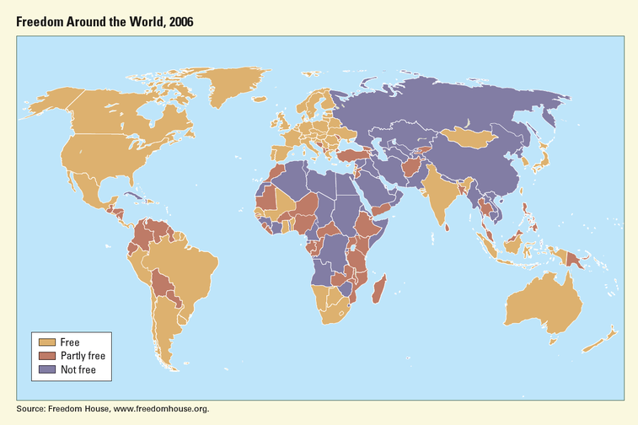

The Arab Uprisings and Their Global Repercussions
by Arch Puddington
The political uprisings that swept across the Arab world over the past year represent the most significant challenge to authoritarian rule since the collapse of Soviet communism. In a region that had seemed immune to democratic change, coalitions of activist reformers and ordinary citizens succeeded in removing dictators who had spent decades entrenching themselves in power. In some cases, protest and upheaval was followed by the beginnings of democratic institution building. At year’s end, two countries with unbroken histories of fraudulent polling, Tunisia and Egypt, had conducted elections that observers deemed competitive and credible, and freedom of expression had gained momentum in many Middle Eastern societies.

Unfortunately, the gains that were recorded in Tunisia, and to a considerably lesser extent in Egypt and Libya, were offset by more dubious trends elsewhere in the region. Indeed, the overthrow of autocrats in these countries provoked determined and often violent responses in many others, most notably in Syria, where by year’s end the Assad dictatorship had killed over 5,000 people in its efforts to crush widespread antigovernment protests. Similar if less bloody crackdowns took place in Bahrain and Yemen.

This pattern of protest and repression—with an emphasis on the latter—was echoed elsewhere in the world as news of the Arab uprisings spread beyond the Middle East and North Africa. In China, the authorities responded to events in Cairo’s Tahrir Square with a near-hysterical campaign of arrests, incommunicado detentions, press censorship, and stepped-up control over the internet. The Chinese Communist Party’s pushback, which aimed to quash potential prodemocracy demonstrations before they even emerged, reached a crescendo in December with the sentencing of a number of dissident writers to long terms in prison. In Russia, the state-controlled media bombarded domestic audiences with predictions of chaos and instability as a consequence of the Arab protests, with a clear message that demands for political reform in Russia would have similarly catastrophic results. In other Eurasian countries and in parts of Africa, the authorities went to considerable lengths to suppress demonstrations and isolate the democratic opposition.

The authoritarian response to change in the Middle East had a significant impact on the state of global freedom at year’s end. The findings of Freedom in the World 2012, the latest edition of Freedom House’s annual report on political rights and civil liberties, showed that slightly more countries registered declines than exhibited gains over the course of 2011. This marks the sixth consecutive year in which countries with declines outnumbered those with improvements.

Arch Puddington is Vice President of Research for Freedom House.

