Economics
Chapter 15- The United States and the Global Economy

1. Introduction
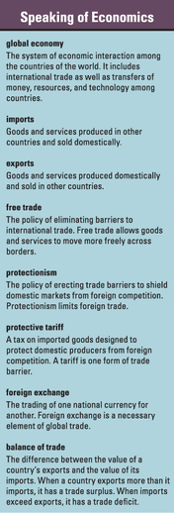

In 1971, Marc McCreary and his family opened a T-shirt factory in Florence, Alabama. Within a few years, his business was booming, with over 1,000 employees and millions of dollars in sales. Other T-shirt factories also opened in Florence, as people hoped to cash in on the growing market. Florence began calling itself the “T-Shirt Capital of the United States.”
But then the boom went bust. In the early 2000s, imported T-shirts from China and other low-wage countries began flooding the U.S. market. These shirts were comparable in quality to American shirts, but much cheaper. Florence's factory owners tried to boost productivity and lower costs, but in the end they could not compete. “You can't fix this by working harder,” McCreary later told a reporter for National Public Radio. “This is a global situation. None of us could figure this out.”
In 2003, McCreary had to close his factory and lay off his workers. The other T-shirt firms in Florence also shut down. Thousands of people lost their jobs, and the economy of Florence suffered a major blow.
For a few years the city struggled with the effects of the plant closings. Then it began to recover. Some laid-off workers enrolled in retraining programs to learn new skills. Others opened their own small businesses. Outside firms, including some foreign companies, relocated to Florence to take advantage of the area's skilled workforce. Although some laid-off workers had trouble getting back on their feet, most moved on to new and even better jobs.

The story of Florence and the T-shirt industry reflects changes in the American economy as it becomes increasingly tied to the global economy. The global economy is the system of markets and trade that links the countries of the world. Economists generally agree that, despite the challenges of foreign competition, the benefits of participating in the global economy far out-weigh the costs. This chapter focuses on one of the most important aspects of the global economy—global trade—and its role in shaping the U.S. economy. It also looks at the financial system that makes trade across borders possible.

2. Why Is Global Trade Growing in Importance?
Take a look at the label on your shirt. Does it say “Made in U.S.A.”? Chances are that it does not. Although Americans can still buy clothing made in U.S. factories, most of the apparel sold in this country is produced in other countries. The same is true for electronic goods and many other products. The abundance of foreign-made goods in American markets underscores the increasing importance of global trade.
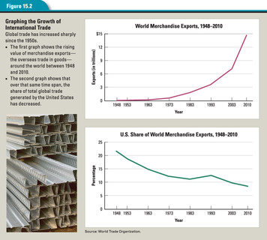

The Growth of Global Trade
As Figure 15.2 shows, international trade has grown dramatically since the end of World War II. Over the past half-century, the worldwide trade in merchandise, which includes all types of goods, has expanded more than 245 times, or by 24,500 percent. A number of developments have combined to make this increase in global trade possible.
First, advances in transportation have had a major impact on cross-border trade. It is easier to move goods around the world than ever before. Ships are far larger today than they were 50 years ago, enabling them to carry more goods at a lower cost per unit. Container ports have facilitated shipping by allowing the loading and unloading of whole containers of goods. The development of wide-body, long-distance jet planes has made air transport cheaper and faster. As a result, perishable goods such as fresh fruits and vegetables can be shipped thousands of miles without spoiling.
Improved communications have also fueled the growth of global trade. Satellite systems now link computers and telephones around the world, making it possible to communicate almost instantly across great distances. A company in one country can serve its customers in another almost as easily as if they were in the same city. Global business can be transacted, and money can be exchanged, with just a few keystrokes.
A shift in the types of goods being produced and traded has further promoted global commerce. At one time, much of the trade between countries was in bulk commodities, such as grains, coal, and steel. These items were heavy and relatively hard to ship. Today a large share of global trade is in lighter manufactured goods, such as computers and other electronic devices, which are easier to transport and which sell for much higher prices.

Why Countries Trade: Absolute and Comparative Advantage
Countries trade with each other for the same reason individuals do: to get the goods and services they value at the lowest cost. Most countries lack either sufficient resources or large enough markets to produce everything their people would like to consume for themselves. A country like the United States, however, is rich enough and big enough to produce virtually everything it needs.
Nonetheless, the United States and other large, wealthy countries still engage in trade with other countries. Why? Because even rich countries benefit when they specialize in the production of some goods and services and trade those products for other goods and services. Decisions about what to specialize in reflect a country's absolute and comparative advantages.
As you read earlier, a country has an absolute advantage in trade if it can produce something more efficiently than other countries can. Such an advantage might come from a country having access to a scarce resource or having the ability to produce something more cheaply than other countries can. For example, South Africa's rich diamond deposits give it an absolute advantage in diamond production.
A country has a comparative advantage in trade when it can produce a good or service at a lower opportunity cost than its competitors can. For example, the United States and Canada are both capable of producing jet airplanes and wood products. But the opportunity cost of producing timber is lower for Canada than it is for the United States, and the opportunity cost of producing jet airplanes is lower for the United States than it is for Canada. So it makes sense for the United States to trade its relatively cheaper airplanes for Canada's relatively cheaper timber. By specializing, both countries get the goods they want at a lower cost than if they tried to produce both goods for themselves.
One country's comparative advantage over another might stem from any of several differences between them. Three of the most important are differences in climate, factors of production, and technology.
Differences in climate. Many countries have a comparative advantage in the production of certain crops based on climate. Tropical countries export warm-weather crops like mangos, bananas, and coffee. Countries with temperate climates trade grains like wheat and corn. Seasonal variations between the Northern and Southern hemispheres can also play a part. For example, during the winter months the United States and Europe buy fruits and vegetables from southern countries such as New Zealand and Chile, which are then in their summer growing season.
Differences in factors of production. Countries with an abundance of a particular factor of production—land, labor, or capital—may have a comparative advantage in the production of goods derived from that resource. Canada, for example, with its extensive forestland, has a comparative advantage in timber products. China, with its huge population, has an advantage in the production of goods like clothing that require large amounts of low-cost labor. Japan, with its high national savings rate, is able to specialize in industries that require a lot of investment capital, like automobile manufacturing.
Differences in technology. Countries that have developed high levels of technology also enjoy a comparative advantage in producing high-value goods. Japan's advantage in auto production is in large part a result of advances in engineering and production methods. Similar advances in the software and pharmaceutical industries have given the United States and Europe a comparative advantage in those fields.

Differentiated Products Promote Global Trade
Global trade is not solely a matter of absolute or comparative advantage. After all, many countries are equally efficient at producing all kinds of goods—cars, foods, movies, clothing. They do not have a particular advantage in the production of such goods, and yet they trade them nonetheless.
The reason is simple. Consumers enjoy the variety created by differentiated products. Differentiated products are products that are essentially the same, but are distinguished from each other by variations in style, materials, or taste.
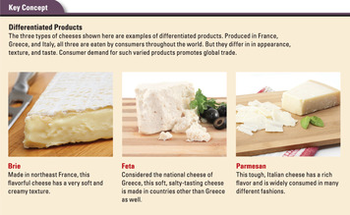
Consider a commonplace food like cheese. All cheese is basically the same—a product made of cultured milk. Looked at that way, one type of cheese is pretty much the same as another. But consumers who buy cheese do not look at it that way. Cheese is a differentiated product. The unique tastes and textures of the many varieties are strong selling points for consumers. Shoppers tend to seek out specific cheeses—French brie, Greek feta, Italian parmesan—to suit their particular tastes and menus. This demand drives the international trade in cheeses.
The same principle applies to other products and countries. Consumers may seek out leather shoes and handbags from Italy, popular music from Great Britain, or animated movies from Japan.Economists note that differentiated products like these are an increasingly important factor in global trade.

3. What Goods and Services Do Countries Trade?
In 2005, Sara Bongiorni and her family carried out an unusual experiment. They tried to live the entire year without buying any products made in China. Bongiorni chronicled the experience in her book, A Year Without “Made in China”: One Family's True Life Adventure in the Global Economy. The author discovered that Chinese goods are everywhere in the American marketplace. Even American flags are made in China. She came away from that year with a deeper understanding of U.S. ties to the global economy.
The United States not only imports products from abroad. It also exports goods and services to other countries. Imports are products made in another country and sold domestically. Exports are products made domestically and sold in another country. In the global trading system, one country's exports become another country's imports, and vice versa.
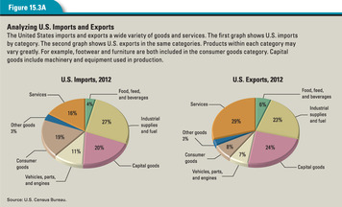

The United States as a Major Importer
As Sara Bongiorni found out in her year without China, the United States is the world's leading importer of goods and services. In 2012, it imported about $500 billion worth of goods more than China, the second largest importer.
The first graph in Figure 15.3A shows the kinds of goods and services the United States imported in 2012 by category. The largest category that year was industrial supplies and fuels. This category includes chemicals, minerals, wood products, cotton, petroleum products, and other fuels. Within this category, far more money was spent on imported crude oil than on any other good.
The second largest category of imports in 2012 was capital goods. Included in this group are goods that are used in the production of other goods and services. Examples of capital goods include machines, computers, measuring instruments, and telecommunications equipment.
Consumer goods other than automobiles ranked third. This category includes all types of products for personal and home use, ranging from household appliances, televisions, and furniture to clothing, jewelry, and cosmetics.

The United States as a Major Exporter
The United States is also one of the world's top three exporting countries, along with Germany and China. Its exports range from farm products, minerals, and manufactured goods to financial and transportation services. The second graph in Figure 15.3A shows the kinds of products U.S. producers export by category.
Capital goods make up a large portion of U.S. exports. Among the most valuable exports in this category are semiconductors, civilian aircraft, industrial machinery, and telecommunications equipment. The United States has a comparative advantage in exporting such high-tech goods because of its high levels of human capital.
At first glance, it might seem odd that the United States both imports and exports the same types of goods, such as automobiles and telecommunications equipment. The explanation for this paradox lies in product differentiation. German cars and American cars, though similar, are not the same. There is a market for German cars in the United States and a market for American cars in other countries.
In the case of telecommunications equipment, the products differ more substantially. The United States imports cell phones and exports satellite communications equipment. The United States does not have a comparative advantage in cell phone production, but it does have an advantage in satellite technology. Therefore, it makes sense for the United States to export satellite devices and import cell phones.
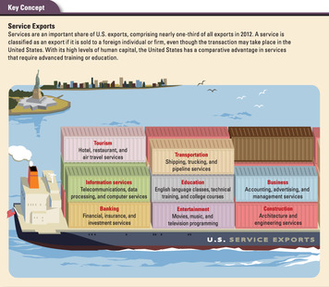

The Growth of Service Exports
Services also make up a significant share of U.S. exports. In 2012, services accounted for almost one-third of all exports. The illustration below shows the kinds of services the United States exports by category. As with manufactured goods, service exports reflect the country's comparative advantage in fields requiring a highly trained workforce. Such fields include engineering, education, and information services.
You might be wondering how a service, which is not a physical object, can be exported. Every time an American company sells a service to a foreign customer, whether in the United States or abroad, it is exporting that service. For example, when a foreign student pays to attend college in the United States, that education is considered a service export. Likewise, when a foreign traveler pays for a hotel stay in a U.S. city, that payment is classified as a service export. American banks, airlines, insurance companies, and shipping agencies all add to U.S. export totals when they do business with foreign clients. So, too, do entertainment companies when they sell American movies or musical recordings to customers overseas.
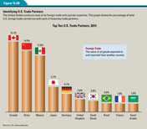

America's Trading Partners
The United States trades with most countries in the world. However, it conducts more than half of its foreign trade with just ten countries. Figure 15.3B shows America's top ten trading partners in 2012.
Canada has long been America's chief trading partner. The long border between the United States and Canada and the traditionally good relations between the two countries have contributed to the growth of U.S.-Canadian trade. In 2012, Canada accounted for about 16 percent of U.S. foreign trade.
After the signing of the North American Free Trade Agreement (NAFTA) in 1994, Mexico became this country's second most important partner in trade. From time to time, however, growing trade with China has pushed Mexico into third place.
Around half of U.S. trade is with wealthy, industrialized countries such as Germany and Japan. The other half is with newly industrialized countries such as China and oil-exporting countries like Venezuela and Saudi Arabia.

The Benefits of Global Trade for U.S. Consumers
Trade with other countries has many benefits for U.S. consumers. Global trade gives us access to an enormous variety of goods and services. We also enjoy low prices for many goods because we import these goods from low-cost producers. This makes us better off. As economics writer Charles Wheelan points out, “Cheaper goods have the same impact on our lives as higher incomes. We can afford to buy more.” As a result, our standard of living improves.
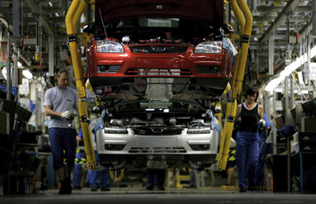
Global trade also increases competition among producers. This may cause some producers to go out of business, as it did the T-shirt makers of Florence, Alabama. At the same time, it creates new opportunities for innovative or low-cost producers to enter the marketplace. Moreover, the producers that survive become more efficient and productive, thus contributing to a healthier economy. For example, competition from Japanese and European automakers gives U.S. carmakers a strong incentive to make better vehicles at a lower cost. The resulting improvements benefit anyone who buys an American car, whether in this country or abroad.
Finally, global trade enhances the flow of ideas around the world. The movement of products and services among countries opens societies to new ways of doing things. This exchange of new ideas and technologies promotes further innovation.

The Impact of Global Trade on U.S. Workers
As the story of the Florence, Alabama, T-shirt boom and bust makes clear, global trade can also have negative effects on American workers, at least in the short term. Workers who are employed in industries that fail in the face of foreign competition may lose their livelihoods as a result of global trade. In most cases, laid-off workers find new jobs, but some never manage to recover their former standard of living. This results in real hardship for people and communities.
While some workers may have suffered as a result of global competition, the labor force as a whole has not. In 1971, when Marc McCreary opened his Florence T-shirt factory, the U.S. labor force participation rate was 60 percent. By 2003, the year his factory closed because of cheap imports, the percentage of adults in the labor force had risen to 66 percent.
In the long run, global trade increases economic activity, which in turn, promotes economic growth. Workers who lose their jobs but retrain themselves for new careers generally improve their circumstances. As in any market, competition among buyers and sellers produces winners and losers. But for countries that use their resources wisely and exploit their comparative advantages, the gains created by global trade outweigh the losses.

4. How and Why Do Countries Regulate Trade?
Have you ever tried to mail a package to another country at the post office? If so, you probably had to fill out a customs declaration. It asked you to list the items you were sending and to indicate whether they were gifts or goods to be sold. This information is required by customs—the government department responsible for examining goods entering a country and enforcing any trade restrictions on them.
Economists have long argued against trade restrictions. Nonetheless, few countries have ever fully embraced free trade—the unrestricted movement of goods and services across borders. Over the years, countries have found many reasons to regulate foreign trade.
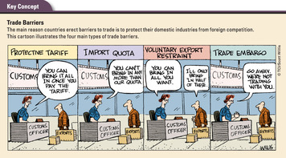

Types of Trade Barriers: Tariffs, Quotas, Embargoes, and Voluntary Restraints
Many countries restrict imports in order to shield domestic markets from foreign competition. Such behavior is known as protectionism. Countries do this mainly to satisfy political demands at home.There are many types of trade barriers. The four main types are protective tariffs, import quotas, trade embargoes, and voluntary export restraints.
Protective tariffs. The most common type of trade barrier is the protective tariff—a tax on imported goods. Countries use tariffs to raise revenue and to protect domestic industries from competition from cheaper foreign goods. Tariffs are among the easiest taxes to impose, since they arouse little domestic protest and can be easily applied to goods before they enter the country.
While protective tariffs may help specific domestic producers, they do not benefit consumers. Tariffs push up the prices of imported goods. So instead of having to lower prices to compete with cheap imports, domestic producers can raise prices to the inflated price level of the imports. Thus, tariffs make all goods more expensive for consumers.
If they are set high enough, protective tariffs can also have negative effects on the entire economy. The Hawley-Smoot Tariff Act, passed by Congress in 1930, raised the average tariff rate on imported goods to more than 40 percent. Although 1,028 economists petitioned President Herbert Hoover to veto the bill, he signed it into law. In response, other countries raised their tariff rates. Foreign trade came to a halt, helping to turn a recession into a worldwide depression.
Despite these drawbacks, most governments are still persuaded that tariffs are needed to protect their country's workers and industries. In 2013, for example, the United States charged a 4.7 percent tariff on imported pianos, a 6.8 percent tariff on cut roses, and a 6.6 percent tariff on mechanical pencils.
Import quotas. While tariffs make foreign goods more expensive, they do not limit the quantity of goods that can be imported. An import quota, on the other hand, places a limit on the quantity of a good that can be imported during a specified period of time. For example, an import quota on textiles might limit textile imports from a given country to 10 million garments per year. Once that limit is reached, textile imports from that country must stop for that year.
Beginning in the 1960s, textile quotas were used by the United States and other countries to shield their domestic clothing industries from competition from low-wage countries. The phasing out of these quotas in the 1990s caused an upsurge in inexpensive clothing imports. Many U.S. apparel companies went out of business as a result, including the T-shirt makers of Florence, Alabama.
Like tariffs, quotas are designed to protect domestic industries. But they do not raise revenue for the government. They may also lead to corruption and smuggling as producers look for ways to exceed quota limits. Like tariffs, import quotas raise prices for consumers as costlier domestic items replace cheaper imports once the quota limit is reached.
Trade embargoes. A trade embargo imposes a ban on trade with a country or group of countries, usually for political reasons. For example, in 1960 the United States imposed a trade embargo on Cuba to protest its revolutionary government's seizure of American-owned property. In 1986 the U.S. Congress imposed an embargo on South Africa to oppose its apartheid policy of racial segregation.
Trade embargoes have a mixed record. When successful, they pressure countries to change their policies. South Africa, for example, abandoned its racial segregation policies when faced with trade embargoes from many countries. In contrast, as of 2013, the decades-long U.S. trade embargo against Cuba had failed to bring about a change in the country's government or policies.
Voluntary export restraints. The fourth type of trade barrier is known as a voluntary export restraint, or VER. This type of barrier limits the quantity of a good that can be exported from a country during a specific time period. In effect, it is an export quota, self-imposed by the exporting country.
In most cases, however, a VER is not truly voluntary. It is usually established at the insistence of an importing country. It is designed to avoid harsher restrictions, such as tariffs or import quotas. For example, Japan imposed a VER on its automobile shipments to the United States in the 1980s when faced with U.S. threats to restrict Japanese auto imports.
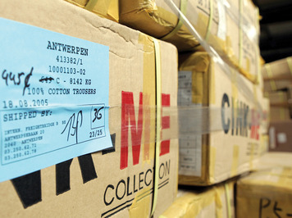

The Debate over Trade Restrictions
People have long debated the merits of free trade versus protectionism. Economists generally agree that free trade promotes economic growth and is good for consumers. Still, domestic producers, labor unions, and political leaders continue to make the case for trade restrictions. They base this position on a number of key arguments.
The jobs argument. This argument assumes that allowing cheap imports into a country destroys jobs by forcing domestic companies to cut costs, lay off workers, or even go out of business. Protectionists might point to the collapse of the Florence, Alabama, T-shirt industry to support this case.
According to the jobs argument, highly paid workers in a wealthy country like the United States simply cannot compete with low-wage workers in poorer countries. The only way to protect American jobs is to make cheap imports more expensive by imposing tariffs or to limit their availability by imposing quotas.
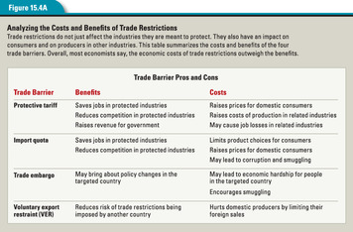
Economists reply that tariffs and quotas cost more jobs than they save. For example, in the 1980s the United States imposed tariffs on imported steel to protect the domestic steel industry. The tariffs led to higher steel prices. Higher steel prices raised the cost of producing goods made with steel, from pots and pans to automobiles. This hurt domestic producers of such goods, who had to compete with foreign producers using cheaper steel.
By one estimate, the steel tariffs earned roughly $240 million in profits for U.S. steel companies and saved 5,000 jobs. But they cost domestic industries that use steel $600 million in profits and 26,000 jobs.
Most economists also dismiss the idea that American workers cannot compete with foreign labor. Low wages in poor countries, they say, reflect low productivity. The cost to an employer of a high-wage worker who is very productive may be less than that of a low-wage worker who is less productive. Free trade encourages firms to specialize in those activities in which their workers are relatively more productive.
Finally, economists note that while free trade destroys some jobs, it also creates jobs. It does so by expanding the industries in which the United States has a comparative advantage. It helps U.S. export industries, since buying imports from foreign countries gives those countries the purchasing power to buy American goods. It also creates jobs for retailers and businesses that sell and service imported goods.
The national-security argument. This argument states that industries that are vital to national security must be protected. Included in this category are defense industries and producers of critical resources like oil and steel. Some would even extend this argument to include the production of basic foods, such as wheat and corn. Those who make this argument say trade restrictions are needed to avoid dependence on foreign suppliers during times of conflict.
Most economists would agree that when the country's security is at stake, trade barriers may be justified to protect key industries. But they are skeptical when calls for such protection come from industry representatives rather than military or intelligence agencies. Industries that are facing stiff foreign competition have an interest in proclaiming their own importance to the country's security.
The infant-industry argument. Sometimes a newly formed industry needs time to become competitive. According to this argument, such “infant industries” will eventually become strong enough to stand on their own. In the meantime, protectionists say, tariffs may be necessary to protect them from cheaper imports.
Economists typically respond that even if one accepts this argument, it is difficult to put into practice. It requires that the government identify which infant industries will eventually make a profit and are therefore worth protecting. In reality, making this selection is notoriously difficult, and the process is all too easily influenced by politics.
Economists also object to the infant-industry argument on principle. New firms, they argue, must be willing to accept losses when starting up if they believe they can become profitable in the long run. Moreover, many new firms have grown into industry giants.
The unfair-competition argument. This argument asserts that trade is fair only if all countries play by the same rules. For example, protectionists argue that some countries “cheat” by providing subsidies to their industries to help them compete with foreign firms. They say that trade barriers are justified to protect domestic industries from subsidized foreign imports.
Protectionists also contend that some countries “dump” their products in foreign markets to force competitors out of business. Dumping means selling a product for less than it cost to produce it. Dumping is considered an unfair trade practice by most trade organizations, and most countries disavow it.
Economists typically reject both parts of the unfair-competition argument. First, they assert that the benefits to consumers of cheap imports outweigh the costs to domestic producers, regardless of whether the imported products are subsidized or not. Second, they say it is nearly impossible to detect dumping because it is difficult to determine a foreign firm's costs. “Often,” write economists Campbell McConnell and Stanley Brue, “what appears to be dumping is simply comparative advantage at work.”
The protection-as-bargaining-chip argument. This argument states that trade restrictions can be a useful bargaining tool in trade negotiations with other countries. Its advocates claim that the threat of a tariff or import quota can be used to persuade another country to remove or reduce its barriers to trade.
Economists point out that this strategy can easily backfire. When that happens—when the threat of a new trade restriction does not produce the desired result—the country faces a dilemma. It either has to make good on its threat and impose the restriction (which might harm its economic welfare) or back down (which can harm its reputation). Either of these results leaves the country worse off than before.
The environmental-and-labor-standards argument. Some people contend that countries with lax environmental or labor laws have an economic advantage over countries that must comply with stricter laws. To make trade fair, they say, countries with stricter laws should impose tariffs against countries that do not uphold similar standards.
The problem with this argument, say most economists, is that lax standards are most common in the world's poorer countries. These countries have few resources to devote to worker and environmental protection. As they develop their economies, in part through global trade, they will be able to pay more attention to labor and environmental standards. Restricting trade with such countries only slows the pace at which such improvements can be made.

Why Trade Restrictions Are Still Widespread
If the view of most economists is correct and trade restrictions do more harm than good, then why do political leaders and the general public still support them? The answer lies in the political process. Producers and workers who are threatened by foreign competition typically organize to seek trade protection. They lobby members of Congress and educate the public on the subject.
On the other hand, those who benefit from free trade—the great majority of consumers—may not even realize that their interests are at stake. And so, as the following analysis points out, they do little to oppose trade restrictions:
The overall cost of tariffs and quotas typically greatly exceeds the benefits. It is not uncommon to find that it costs the public $200,000 or more a year to protect a domestic job that pays less than one-fourth that amount. Moreover, because these costs are buried in the price of goods and spread out over millions of citizens, the cost born by each individual citizen is quite small. In the political arena, the voice of the relatively few producers demanding protectionism is loud and constant, whereas the voice of those footing the bill is soft or nonexistent.
—Campbell R. McConnell and Stanley L. Brue, Economics: Principles, Problems, and Policies, 2008
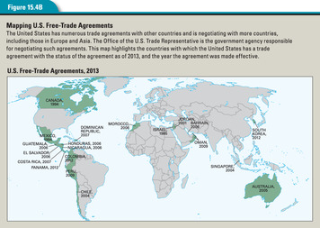

Reducing Trade Barriers Through International Agreements
Countries do have incentives to promote free trade, however. The chief incentive is to be able to sell their products abroad and earn export revenues. For that reason, countries have negotiated international trade agreements to reduce trade barriers. Figure 15.4B shows U.S. free-trade agreements around the world.
Some trade agreements involve just two or three countries or a particular region. For example, the North American Free Trade Agreement includes just Canada, Mexico, and the United States. The European Union, established in 1993, included 28 member countries by 2013. Both these regional agreements reduce tariffs and promote trade among their members.
The first trade agreement to involve a large number of countries was the General Agreement on Tariffs and Trade. When adopted by 23 countries in 1948, GATT lowered tariffs on tens of thousands of goods.
In 1995, the members of GATT formed the World Trade Organization. Since its formation, the WTO has overseen various international negotiations aimed at reducing trade barriers. It has also worked to resolve trade disputes among its members. By 2013, the WTO consisted of 159 member countries, all of which agree to abide by WTO rules.

5. How Is Global Trade Financed?
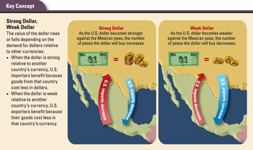
For countries to trade goods and services, they must also trade their currencies. If you have ever visited a foreign country, such as Mexico, you know that you must exchange your dollars for Mexican pesos in order to shop while you are there. The same is true for U.S. businesses that want to buy goods or services in Mexico. Likewise, a Mexican firm that wants to buy American goods must trade its pesos for dollars. The process of converting one currency to another is known as foreign exchange. Without the exchange of currencies, little or no global trade would take place.

Foreign Exchange and Exchange Rates
Foreign exchange takes place on the foreign exchange market. This market is made up of major banks and financial institutions around the world that buy and sell currencies.
Each currency traded in the foreign exchange market has an exchange rate. This rate indicates the value of one currency in terms of another. For example, if you can exchange one U.S. dollar for 10 Mexican pesos, the dollar exchange rate is US$1 = 10 pesos. The Mexican peso exchange rate would be 1 peso = US$0.10.
Exchange rates typically fluctuate based on supply and demand. If Americans are buying lots of goods and services from Mexico, they will need lots of pesos. Because the price of something generally rises with demand, a strong demand for pesos tends to raise the price of pesos in terms of dollars. That is, it will take more dollars to buy the same number of pesos. The exchange rate might fall from US$1 = 10 pesos to US$1 = 9 pesos. The dollar would then be worth less in pesos. When one currency loses value relative to another currency, we say depreciation has occurred.
Conversely, if Mexicans are buying lots of U.S. goods and services, the demand for dollars in Mexico will increase. That, in turn, will cause the price of the dollar to rise relative to the peso. So, for example, instead of getting 10 pesos for one dollar, you might get 11 pesos. When one currency gains value relative to another currency, we say appreciation has occurred. Note that when comparing two currencies, the appreciation of one means the depreciation of the other.
When a currency appreciates in value, it is said to get stronger. When it depreciates, it is said to get weaker. Thus, a strong dollar has a higher exchange rate and trades for more foreign currency than a weak dollar.
Whether a country's currency is strong or weak has important effects on its cross-border trade. When the dollar is weak, foreign goods and services cost more in dollars. This tends to discourage imports into the United States. At the same time, a weak dollar makes U.S. exports relatively cheap for other countries, since their currencies are strong relative to the dollar. Thus, a weak dollar is likely to boost U.S. exports. When the dollar is strong, the reverse occurs. Imports from other countries become cheaper, while exports become more expensive.
Although many people regard a strong dollar as good and a weak dollar as bad, it is really a matter of perspective. A weak dollar can be hard on consumers, who pay more for imports, but good for those producers who primarily export their products. When the dollar is strong, on the other hand, consumers may benefit and producers may suffer.
There are exceptions to this general rule. Producers who depend on imported parts for their products, for example, may not benefit from a weak dollar. And consumers whose jobs depend on exports may not benefit from a strong dollar. Generally, countries try to strike a balance between high and low exchange rates while achieving some stability relative to other currencies.
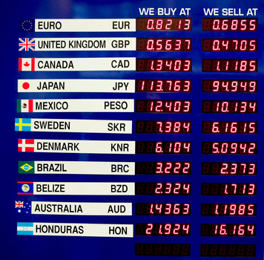

Exchange Rate Systems: Fixed and Floating
An exchange rate that fluctuates based on supply and demand is called a floating exchange rate because rates “float” up and down based on the market. This is the dominant system in the world today.
Some countries take a different approach, however. They establish a fixed exchange rate to keep their currency stable. Under a fixed system, the government typically fixes, or “pegs,” its currency to another major currency, such as the dollar. For example, Mexico might establish a fixed exchange rate of 10 pesos to the dollar and seek to maintain that rate rather than let the peso's value float up and down on the open market.
Both types of exchange rates have their advantages and disadvantages. The main advantage of floating rates is that they reflect supply and demand in the financial markets. The main disadvantage is that they are unpredictable. An unexpected rise or fall in a currency's exchange rate can have negative effects on a country's economy by disrupting trade.
Fixed rates, on the other hand, are predictable. They allow businesses and the government to make economic plans based on a constant value for the currency. Nevertheless, a fixed rate system runs into trouble when a currency's exchange rate no longer reflects what the market says it is worth. When this happens, a government may have to intervene in financial markets to preserve the value of its currency. It does so using reserves of currency, which it holds for this purpose.
For example, if the value of the peso compared to the dollar were to fall too low, the Mexican government could buy pesos on the open market. It would pay for them with dollars from its currency reserves. This would increase the demand for pesos while reducing their supply, thus increasing their value. At the same time, it would increase the supply of dollars on the market, decreasing their value. The result would be to push up the value of the peso.
Were the value of pesos to climb too high, the government could step in to devalue its currency. It would do so by selling pesos from its reserves for dollars. This action would increase demand for dollars while reducing their supply. And it would decrease demand for pesos while increasing their supply. The result would be a devaluation of the peso relative to the dollar.
Since the 1970s, most industrialized countries, such as the United States and Japan, have allowed their currencies to float in a managed way. Other countries with less stable currencies have pegged them to a major currency, such as the dollar or the euro, the common currency of the European Union.
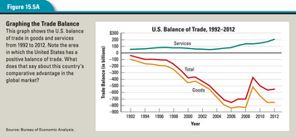

Imports, Exports, and the Balance of Trade
Another way countries try to manage the value of their currency is by regulating their balance of trade. Balance of trade is the difference between the value of a country's exports and the value of its imports. Also known as net exports, it is calculated by subtracting imports from exports.
A country's balance of trade can be positive or negative. If a country exports more than it imports, it has a positive balance of trade, or a trade surplus. If it imports more than it exports, it has a negative trade balance, or a trade deficit. Figure 15.5A shows the U.S. balance of trade in goods and services over time.
A trade surplus helps to strengthen a country's currency. Think about what would happen if the United States had a trade surplus. The number of dollars coming into the United States from the sale of exports would exceed the number of dollars we send to other countries to pay for imports. As the supply of dollars held by people in other countries dropped, the value of the dollar would likely rise.
In the same way, a trade deficit tends to weaken a country's currency. Again consider the situation of the United States, which has run a trade deficit for years. To pay for all of its imports, the United States has to send more and more dollars to its trading partners. As the supply of dollars held by people in other countries rises, the value of the dollar is likely to drop. Thus, by exporting more or importing less, a country can have some effect on the strength of its currency.
Just as a weak currency is not necessarily bad, a trade deficit does not necessarily signal a struggling economy. In 2012, the U.S. trade deficit amounted to more than $500 billion. Yet the United States also had the world's largest economy that year.

Financing the U.S. Trade Deficit
When the United States runs a trade deficit, it means that the country is buying more than it is selling in world markets. How does the country manage to do this year after year?
The United States finances its trade deficit by borrowing dollars from foreign lenders and by selling U.S. assets to foreign investors. In other words, foreigners enable the United States to run deficits. They are willing and able to do this because they have so many surplus dollars from selling us their goods.
Foreigners holding dollars can lend their dollars to the United States by buying Treasury securities or other types of bonds. In 2013 foreigners held more than $5.6 trillion in U.S. Treasury securities alone. This amounted to almost 48 percent of all publicly held U.S. government bonds.
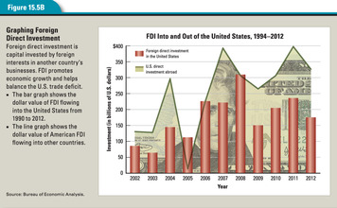
Foreign investors can also purchase stock in American companies or buy U.S. assets, such as farmland and office buildings. Some foreign companies use their dollars to buy American companies or to establish new businesses in the United States.
Investment by a firm in a business enterprise in a foreign country is known as foreign direct investment (FDI). A German or Japanese auto company creating an assembly plant in the United States is an example of foreign direct investment. In 2012, FDI in the United States was around $175 billion.

Concern About the U.S. Trade Deficit
How concerned should Americans be about the United States's consistent trade deficit? The answer depends on whom you ask. A 2005 Wall Street Journal editorial found little cause for concern: “On the list of economic matters to worry about, ‘the trade deficit' is about 75th—unless politicians react to it by imposing new trade barriers or devaluing the currency.” The New York Times, on the other hand, in reporting on the 2006 trade deficit, wrote, “A growing trade deficit acts as a drag on overall economic growth.”
Many Americans are understandably concerned about trade deficits. Such concern is rooted in personal experience and common sense. After all, if you spend more than you earn, you go into debt. If you borrow to finance your debts, you go deeper into debt. This endless borrowing can get a person into serious financial trouble.
Many people view the U.S. trade deficit in much the same way. The United States, they argue, cannot continue to run large deficits and finance them with foreign borrowing forever. At some point, we may have to pay off all that debt, which could prove painful. Moreover, many Americans do not like the idea of foreign firms owning and controlling U.S. land and businesses.
Economists differ on the significance of the trade deficit and the resulting U.S. debt owned by foreigners. Thomas Sowell notes that the United States has been a debtor country for much of its history. In the 1800s, foreign loans and investment helped finance the country's economic development. “There is nothing wrong with this,” he writes, and continues,
By creating more wealth in the United States, such investments created more jobs for American workers and created more goods for American consumers, as well as providing income to foreign investors . . . Neither the domestic economy nor the international economy is a zero-sum process, where some must lose what others win. Everyone can win when investments create a growing economy. There is a bigger pie, from which everyone can get bigger slices.
—Thomas Sowell, Basic Economics, 2007
Sowell and other economists point out that the trade deficit is not a problem as long as our economy grows. When times are good, foreigners view the United States as a safe place to invest their dollars. But the deficit and debt could become an issue if the economy falters. Foreigners may then become less eager to make new loans to the U.S. government. And old loans will have to be repaid—by taxpayers like you. As economists Robert Frank and Ben Bernanke note,
Foreign loans must ultimately be repaid with interest. If the foreign savings are well invested and the U.S. economy grows, repayment will not pose a problem. However, if economic growth . . . slackens, repaying the foreign lenders will impose an economic burden in the future.
—Robert H. Frank and Ben S. Bernanke, Principles of Economics, 2007
The trade deficit may not be high on your personal worry list. But the global economy is bound to play a large role in your life. You are already a participant in that economy every time you buy goods made in other countries. And whatever career you choose, it is likely to involve the global marketplace in some way. Understanding how global trade works will help you make better choices, whether you are hunting for the best deal or the ideal job.

Summary
The United States plays an active part in the global economy. U.S. trade with other countries has expanded in recent decades and has contributed to economic growth both at home and abroad.
Why is global trade growing in importance? Various factors have contributed to the growth of global trade. Chief among these are advances in transportation and communications, which have made it easier for countries to do business and move goods around the world. New and differentiated products have also stimulated global trade.
What goods and services do countries trade? Manufactured products are the main category of exports among nations. Agricultural and mineral commodities—notably oil—are also important. Services in such areas as finance, transportation, education, and information also make up a key component of overseas trade.
How and why do countries regulate trade? Although free trade makes economic sense, most countries find reasons to restrict trade. Usually they do so for political reasons, erecting trade barriers—such as tariffs and quotas—to limit imports in order to protect domestic industries. Such restrictions benefit specific industries at the expense of consumers and producers in other industries.
How is global trade financed? Importers and exporters finance global trade by trading currencies on the foreign exchange market. Exchange rates fluctuate based on supply and demand. Governments may try to influence rates through trade policies and other means. When countries have a negative balance of trade, or a trade deficit, they generally finance their deficit by getting loans or investment capital from abroad.

