Lesson 4 Gains From Trade

Section 1 Introduction

Being a jack-of-all-trades sounds like a good thing, doesn’t it? It seems as if having a wide range of knowledge and skills, as well as the ability to perform many kinds of tasks, would lead to a more productive life. Yet it is not necessarily so. It might be true if you lived alone on a desert island. But for the rest of us, being able to do everything for ourselves might not be an advantage.

To illustrate this fact, economists Robert Frank and Ben Bernanke give us the example of Birkhaman, a man from a poor village in rural Bhutan, a south Asian country that lies north of India and east of Nepal. Birkhaman worked as a cook for a Peace Corps worker stationed in Nepal. Not only was Birkhaman an excellent cook, he could also do many other things. He could butcher a goat, make furniture, thatch a roof, and build a house. He could also sew clothing, fix appliances, craft objects from tin, and even prepare home remedies. In short, Birkhaman was a jack-of-all-trades who had a much wider range of skills and abilities than most Americans.

Frank and Bernanke pointed out that although Birkhaman was very talented, he was by no means unique in Nepal. Many Nepalese can perform a variety of tasks that we, as Americans, would hire others to do. What accounts for this difference?

It might seem that the Nepalese do more things for themselves because Nepal is a poor country where many people cannot afford to pay others for their services. But the economists offered another explanation. They argued that poverty is the result—and not the cause—of the jack-of-all-trades phenomenon in Nepal. “The Nepalese do not perform their own services because they are poor,” Frank and Bernanke wrote. “Rather, they are poor largely because they perform their own services.”

Instead of doing almost everything themselves, Frank and Bernanke argued, poor Nepalese would be better off specializing in the production of particular goods and services. They could then trade among themselves to obtain any goods and services they do not produce. The result, as the trade-makes-people-better-off principle tells us, would be more wealth and a better standard of living.

It may be nice to know how to do many things, but that does not mean it is in your economic interest to do them. In this chapter, we will examine how specialization and trade can make people better off than they would otherwise be.

Section 2 How Does Specialization Lead to Economic Interdependence?

If you had lived in the United States 200 years ago, there is a good chance you and your family, like Birkhaman, would have been much more self-sufficient. You might have grown your own food, built your own house, made your own tools, and performed many other tasks for yourself rather than relying on others.

Although self-sufficiency may be an appealing idea, it is not necessarily economically productive. In fact, societies that emphasize self-sufficiency are less productive and have a lower standard of living than those that rely on specialization and trade. Why should this be the case?

Specialization Improves Productivity
In The Wealth of Nations, Adam Smith wrote about the advantages of specialization, an approach to production in which individual workers become highly skilled at a specific task. Smith illustrated this principle by describing a pin factory:

One man draws out the wire, another straight[en]s it, a third cuts it, a fourth points it, a fifth grinds it at the top for receiving the head; to make the head requires two or three distinct operations . . . I have seen a small manufactory of this kind where ten men only were employed . . . [who] could, when they exerted themselves, make among them . . . upwards of forty-eight thousand pins in a day . . . But if they had all wrought [worked] separately and independently, and without any of them having been educated to this peculiar business, they certainly could not each of them have made twenty, perhaps not one pin in a day.
—Adam Smith, The Wealth of Nations, 1776

Smith’s description illustrates the division of labor that arises from specialization. It also underscores the great efficiency and productivity that result when workers divide the individual tasks that make up a job and become expert at those specific tasks. Smith’s pin workers were far more productive when each worker specialized in one step of the manufacturing process.

What was true for Smith’s pin factory in the late 1700s is also true for an entire economy today. An economy can produce more with the same inputs of land, labor, and capital when each person or business specializes in a skill or task. As productivity increases, more products and services become available to more people, and living standards rise for society as a whole.

If specialization is so great, shouldn’t all societies specialize? The answer, said Smith, has to do with population density and isolation from large markets. He observed, for example, that specialization in the late 1700s was more developed in large British cities than in less-populated rural areas, such as the Scottish Highlands:
In the lone houses and very small villages which are scattered about in so desert a country as the Highlands of Scotland, every farmer must be butcher, baker and brewer for his own family . . . A country carpenter . . . is not only a carpenter, but a joiner, a cabinet maker, and even a carver in wood, as well as a wheelwright, a ploughwright, a cart and waggon maker.

In big cities, however, where the market for each of these jobs was large, different specialists would have performed these tasks. These workers could specialize because they knew that there were enough customers to sustain them. But markets in rural Scotland were too small, and the region too isolated, to support a range of specialists. Therefore, people had to perform a variety of tasks to earn a living and to satisfy their wants.

A similar scenario exists in Nepal, one of the most remote and isolated countries in the world. Nepal actually has a higher population density than many countries, including the United States. But the country’s rugged, mountainous terrain and relatively undeveloped transportation system limit contact among different regions and with neighboring nations. These factors make trade difficult and help keep Nepal’s markets small, thus discouraging specialization.

The United States presents a very different picture. Even the most remote parts of this country are linked to other regions and the rest of the world through an advanced system of transportation and communications. This system promotes trade and the growth of markets and encourages the development of a highly specialized economy.

This specialization is evident in the variety of jobs performed by American workers. The U.S. Department of Labor’s Occupational Outlook Handbook lists thousands of types of jobs. These jobs range from familiar occupations like carpenter, engineer, and teacher to more specialized jobs like budget analyst, recreational therapist, and violin repairer. The people who work in these jobs are specialists, each pursuing a particular career.

Specialization Encourages Trade
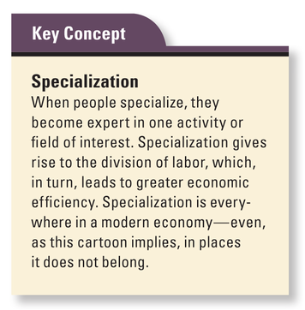
When people specialize, they no longer produce everything for themselves. As a result, they must trade with others to obtain those things they do not produce. They trade not only to satisfy their own wants but also so they can focus on what they do best. As economist and author Charles Wheelan pointed out, “We trade with others because it frees up time and resources to do things that we are better at.”

Wheelan noted that we could, in theory, do many more things for ourselves. We could raise our own livestock, for example, and not have to pay others for meat, milk, and cheese. But that would require an enormous amount of time and energy, and the opportunity cost—as measured by all the other things we could be doing—would be very high. After all, what do most of us know about meat and dairy production? In the end, we are better off when we specialize in activities suited to our skills and trade for everything else.

Trade is a voluntary exchange in which both parties give up something in order to get something else they want. People trade because it is in their mutual interests. As economists James Gwartney, Richard Stroup, and Dwight Lee pointed out in their book Common Sense Economics, “The foundation of trade is mutual gain. People agree to an exchange because they expect it to improve their well-being.”

In traditional economies, trade often takes the form of barter, the direct exchange of one good or service for another. For example, a farmer and a shepherd might agree to barter by exchanging a basket of potatoes for a bag of wool. Barter works well when there is a coincidence of wants—that is, when “you have something I want and I have something you want.”

In market economies, barter is replaced by the use of money. Money is a medium of exchange that can be traded for goods or services or used to pay debts. Money is useful only when its value is generally accepted throughout society. It facilitates trade because it is easy to carry and convenient to use for commercial transactions.

Trade Creates Economic Interdependence
Whether carried out through barter or with money, trade leads to economic interdependence. When we specialize and trade, we depend on other people or countries to produce many of the goods and services we want. A modern economy consists of a complex web of economic links that connect producers and consumers throughout society and across borders.
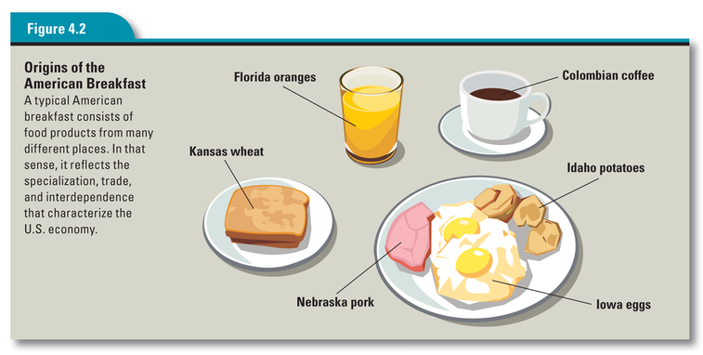c
This economic interdependence is apparent in a typical American breakfast. We might begin with a glass of juice made from Florida oranges. We might follow that with toast made from Kansas wheat, eggs from Iowa, or hash browns made from Idaho potatoes. We might also have coffee made from Colombian coffee beans. In other words, our breakfast depends on food produced by people in many different places.

Like Adam Smith, our country’s founders believed that trade and economic interdependence are essential to the nation’s economic growth. In the years just after independence, they had experienced the problems created when states erected trade barriers against each other. These trade barriers, which included tariffs and other measures to limit interstate trade, were designed to protect local industry and promote self-sufficiency. But they prompted conflicts between states and made it difficult for the country to develop a unified national economy.

The framers of the Constitution encouraged the growth of a national market by giving Congress alone the power to regulate interstate commerce. Article I, Section 8, also known as the Commerce Clause, states, “Congress shall have Power . . . To regulate Commerce with foreign Nations, and among the several States.” This clause empowers the national government to promote trade and economic interdependence among the states. To that end, the federal government maintains an interstate highway system and regulates navigation on interstate rivers and lakes. These government actions contribute to a large and prosperous national economy.

Section 3 How Do People and Nations Gain from Specialization and Trade?

Remember Alexander Selkirk? He was the castaway you read about in Chapter 2 who was stranded on a desert island in the early 1700s.Because Selkirk was alone and had no contact with the outside world, he had no chance to improve his standard of living through trade.

Suppose, however, that a second castaway, Pirate Jack, washed up on the island one day. Now Selkirk would not only have someone to talk to; he would also have a potential trading partner. But would trade make life better for either Selkirk or Pirate Jack? To find out, consider the following scenario.

The Castaways’ Dilemma: Self-Sufficiency or Interdependence
Shortly after Pirate Jack’s arrival, Selkirk tells him about the island’s two main economic activities: gathering wild turnips and digging clams. Right away, the castaways face a critical question: would they be better off working separately and fending for themselves or joining forces and working together?

As it turns out, Pirate Jack is a more efficient worker than Selkirk. He is younger, stronger, and better at almost everything, including gathering turnips and digging clams. As a result, he enjoys an absolute advantage in food production.

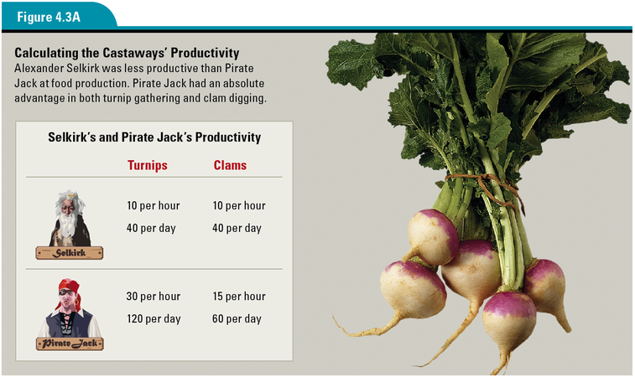

Figure 4.3A shows how many turnips and clams each castaway is able to collect in a given amount of time. Selkirk can gather 10 turnips or dig 10 clams in one hour, for a total of 40 turnips or 40 clams in a four-hour workday. Pirate Jack can gather 30 turnips or dig 15 clams in an hour. In four hours, he can collect 120 turnips or 60 clams.

At first, the two men decide to work together and equally share the food they produce. Pirate Jack soon begins to wonder, however, whether he might be better off moving to the other side of the island and working for himself. Based on his absolute advantage as a food producer, he concludes that it is in his interest to go it alone. At the time, three centuries ago, most people would have agreed with Pirate Jack’s decision.

What Pirate Jack Missed: The Benefits of Comparative Advantage
A century later, however, new economic insights might have led Pirate Jack to a different conclusion. Those insights came from the pioneering work of the English economist David Ricardo, who, in 1817, developed the theory of comparative advantage.

Comparative advantage is defined as the ability to perform a task at a lower opportunity cost than someone else is able to perform that task. Opportunity cost, you will remember, is the value of what you give up to do something. As a producer, you have an absolute advantage if the time and labor required for you to produce something is less than it is for another producer. But you have a comparative advantage if your opportunity cost is less than another producer’s opportunity cost. Ricardo’s breakthrough was to see that, regardless of absolute advantage, people could benefit from specializing in those activities in which they had a comparative advantage.

Ricardo developed this principle in response to new English import tariffs known as Corn Laws. These tariffs placed a tax on imported grain in order to raise its price and protect English grain growers, who could not compete with cheaper foreign grain. This tariff helped farmers and wealthy landowners. But it hurt factory workers, who could not grow their own food and had to pay more for their bread.

Ricardo argued that allowing cheap grain to enter England would force the English to cut back on grain production and to instead concentrate their resources on manufacturing, which was increasingly where their advantage lay. In other words, English producers should specialize in goods in which they had a comparative advantage and then trade with foreign producers. The results, Ricardo said, would benefit society as a whole.
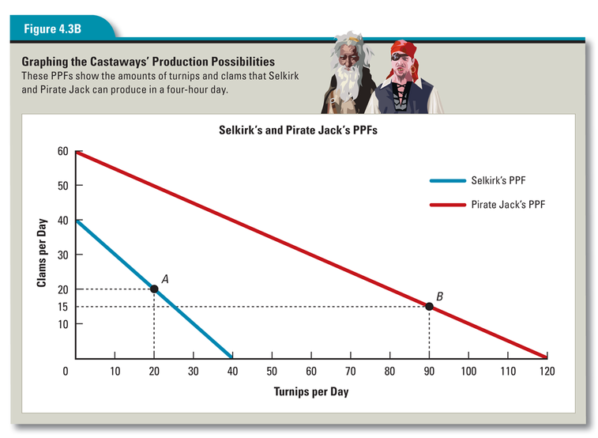

Calculating the Opportunity Costs of Going It Alone
The production possibilities frontiers (PPFs) in Figure 4.3B show how Ricardo’s theory can be applied to Selkirk and Pirate Jack. Remember that a PPF shows how much of two products or services a person or an economy can produce in a given amount of time.

Selkirk’s PPF shows that he can produce 40 turnips or 40 clams in four hours. If he divides his time between the two activities, he can produce a combination of turnips and clams in varying amounts. For example, Point A on the graph indicates that Selkirk can collect 20 turnips and 20 clams in a typical workday.

According to Pirate Jack’s PPF, in addition to his daily rate of 120 turnips or 60 clams, he can produce mixed quantities, such as 90 turnips and 15 clams.This mixed quantity is represented by Point B.
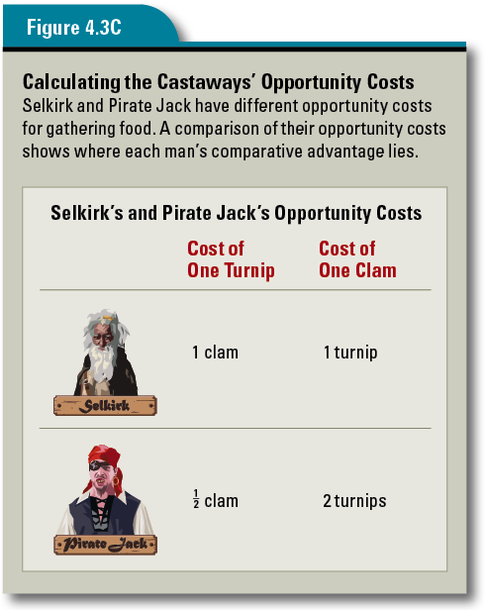
The PPFs clearly show Pirate Jack’s absolute advantage in food production. But do they indicate any comparative advantage for either Selkirk or Pirate Jack? To answer this question, we must first calculate the opportunity cost associated with each activity.

Selkirk’s data show that for every 10 turnips he gathers, he gives up the opportunity to dig 10 clams. So his opportunity cost for each turnip is 1 clam, and his opportunity cost for each clam is 1 turnip.

Pirate Jack has different opportunity costs. For every 30 turnips he gathers, he gives up the opportunity to dig 15 clams. That means that Pirate Jack’s opportunity cost for each turnip is 1/2 clam, while his opportunity cost for each clam is 2 turnips. The opportunity costs for both men are shown in Figure 4.3C.

As the table above shows, Pirate Jack’s opportunity cost for gathering turnips is lower than Selkirk’s: 1/2 clam for Pirate Jack versus 1 clam for Selkirk. This gives Pirate Jack a comparative advantage over Selkirk in gathering turnips. On the other hand, Selkirk’s opportunity cost for digging clams is lower: 1 turnip for Selkirk versus 2 turnips for Pirate Jack. This means that Selkirk has a comparative advantage over Pirate Jack in digging clams, even though he does not have an absolute advantage.

Specialization Based on Comparative Advantage Benefits Both Trading Partners
According to Ricardo’s theory, Selkirk and Pirate Jack should each specialize in the activity in which he has a comparative advantage. That would mean that Selkirk should dig clams and Pirate Jack should gather turnips. They could then trade with each other to obtain the product they do not produce. But would this arrangement work to their benefit?
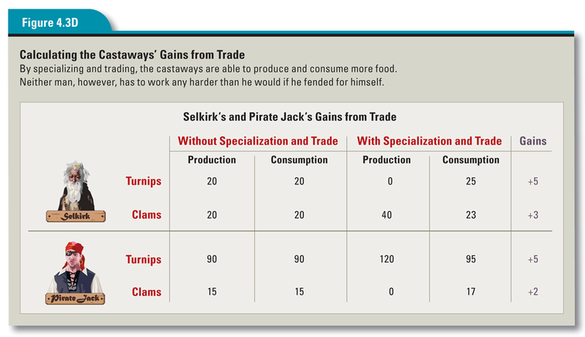

The table in Figure 4.3D shows how each castaway might gain from trading based on comparative advantage. The first two columns of data provide production and consumption values for both men if they do not specialize and trade. These columns contain the values represented by Points A and B from Figure 4.3B.

The next two columns show production and consumption values if the castaways agree to specialize and then trade 17 clams for 25 turnips. The production values show how much each man can produce by specializing. The consumption values indicate how much of both products the men could have if they then traded with each other.

The last column shows what each man has gained from this trade. Selkirk now has the 25 turnips he got from Pirate Jack, along with the 23 clams he did not trade. His decision to trade has resulted in a gain of 5 turnips and 3 clams.

As for Pirate Jack, after trading 25 turnips to Selkirk, he still has 95 left, 5 more than he would have had if had chosen to go it alone. He also has the 17 clams he got from Selkirk, 2 more than he would have had without trade. So both castaways have gained from specialization and trade.
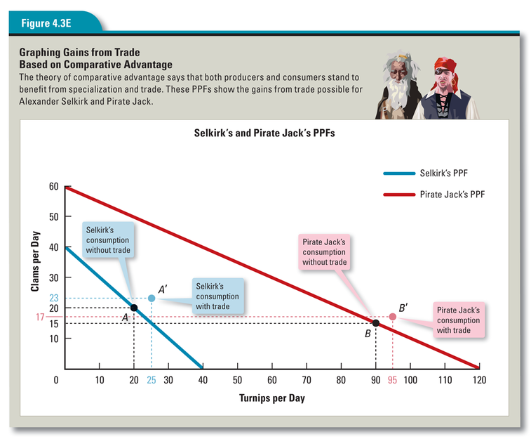

The PPFs in Figure 4.3E show the original production possibilities for the castaways, along with the increased amounts they receive through trade. Those new amounts, represented by Points A’ and B’, sit outside the PPF curve, thus indicating the gains the castaways have made as a result of trade.

Comparative Advantage Applies to Nations as Well as Individuals
What is true for individuals is also true for nations, including the United States. When the principle of comparative advantage is allowed to guide who produces what—for example, Florida farmers growing oranges and Idaho farmers growing potatoes—society usually benefits.

Some of the factors that give rise to comparative advantage, such as climate and natural resources, may be fairly obvious. The main reason Florida has an advantage over Idaho in orange production is that oranges grow better in warm climates. Likewise, Nevada has a comparative advantage in gold production because of its gold deposits. Saudi Arabia excels in oil production because of its abundant oil reserves, while Canada can exploit its vast forests to produce timber. When it comes to farming, mining, forestry, and fishing, geography determines where comparative advantage lies.

Other factors—including education, wage levels, and technology differences—also play a role in determining comparative advantage. The United States, with its many colleges and universities, has a highly skilled, high-wage workforce. This gives the United States a comparative advantage in the development of advanced technologies, such as computer systems. Less-developed nations, on the other hand, tend to have relatively unskilled, low-wage workforces. Such countries often have a comparative advantage in the production of assembly-line goods, like clothing, that do not require highly skilled labor.

The beauty of comparative advantage, as economists see it, is that it stands to benefit all trading partners. Countries that seem to have it all—abundant natural resources, high human capital—can actually gain more by specializing in what they do best and trading with other countries. But even countries with no absolute advantages can come out ahead by finding what they can produce at a lower opportunity cost than other countries—their comparative advantage—and trading.

Section 4 How Does Trade Make Us Wealthier?

The principle that trade makes people better off is fundamental to the economic way of thinking. Another way to state this principle is to say that trade raises our standard of living and makes us wealthier. To appreciate this, try imagining life without the volume of trade we enjoy today.

What would it be like? You might wake up in the morning to a cold house that your family built for itself. Because there would be no gas or electricity, which is only available through trade, you would build a fire from wood you helped to gather and chop. For breakfast you would eat food that your family produced itself, perhaps in a backyard garden. Of course, you would have no appliances to cook with—no toaster or microwave—because these things also depend on trade. You would put on clothes made at home, perhaps using wool from sheep you raised. Then, unless your family owns a horse—cars and bikes are out of the question—you would probably walk to school.

This imaginary scenario gives an idea of how much harder and poorer life would be without trade. The fact is that trade does make us wealthier. Trade does this in three main ways.
• It puts goods in the hands of those who value them.
• It increases the quantity and variety of goods.
• It lowers the cost of goods.

Trade Moves Goods to People Who Value Them
Trade can increase the value of goods, even when nothing new is produced. Think about a secondhand item you might buy at a flea market or garage sale or through an online classified ad. The fact that this item is for sale and that you are willing to buy it means that it has more value to you than to the person who is selling it. Otherwise, there would be no exchange. Trades of this kind move goods from people who value them less to people who value them more. Even though the product has merely changed hands, its value has increased.
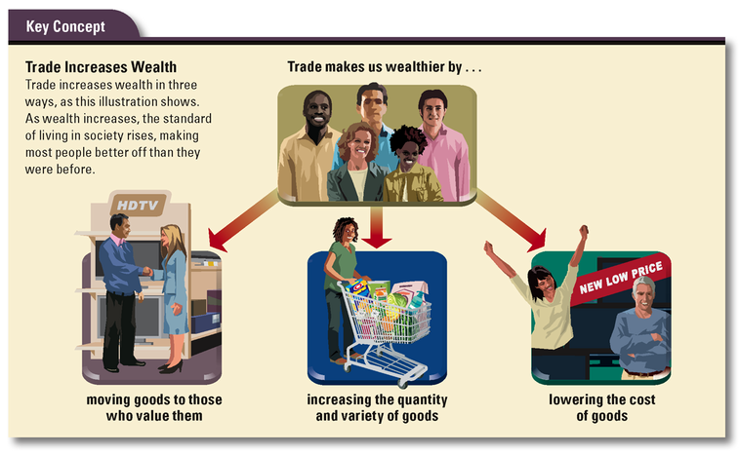
Here is a simple example of how a voluntary exchange can increase the value of goods. Imagine that you own a baseball cap that is practically new but does not fit you. A friend of yours owns a soccer ball she no longer wants. She wants your hat and you want her soccer ball. So you trade. Why? Because you expect to be happier or better off afterward.

When we trade for things we value, our wealth increases. Most people define wealth as money and the things money can buy. But economists define wealth more broadly. Economist Michael Bade defined wealth as the total value of all the things a person owns. Notice that he did not say the total monetary value. This implies that wealth, which is often measured in dollars and cents, can also be measured in other ways. As economist Paul Heyne pointed out, “Wealth, in the economic way of thinking, is whatever people value,” which is another way of saying that trading for a used soccer ball can make you wealthier if a soccer ball is what you really want.

Trade Increases the Quantity and Variety of Goods Available
At the start of this chapter, you read about Birkhaman, the jack-of-all-trades who was skilled at many jobs. In Nepal, where he lived, modern consumer goods are relatively scarce, especially in rural areas. In contrast, the United States and other highly developed nations are awash in consumer goods of all kinds. In part, this is the result of specialization, which allows us to produce more goods for our own use and for trade with other countries. This trade, in turn, gives us access to a range of goods from around the world. As a result, the quantity and variety of goods available to us is enormous.

Just think about the choices you have as a consumer. If you want to buy cheese, for example, you can go to a supermarket and choose from many different kinds. You can buy cheddar or Swiss, Brie or Colby, Monterey Jack or Camembert. And those are only a few of the choices. The variety is mind-boggling.

In Nepal, however, the selection is much more limited, particularly outside the main cities. At a store in a small village, for example, there might be just one type of cheese or perhaps none at all.

This is not to say that life in the United States is better than life in Nepal. The point is that in a specialized economy with abundant trade, the variety and quantity of goods are far greater. As a result, the society is wealthier, and most people are materially better off.

Trade Lowers the Cost of Goods


In addition to making more goods available, trade also lowers the cost of those goods. It can do this in two ways.

First, trade lowers the cost of goods by opening markets to less costly goods from other places. Countries that have a comparative advantage in the production of certain goods may be able to provide those goods to American consumers at a lower cost than American producers can.

Second, trade can lower the cost of goods by expanding markets for products. Larger markets, in turn, allow producers to take advantage of the savings that come with mass production, or large-scale manufacturing. For example, a company that produces thousands of loaves of bread each day might be able to buy its flour at a much lower cost than could a small neighborhood bakery. It can then pass those savings along to consumers by lowering the price of its bread.

Trade Creates More Winners than Losers
Overall, nations benefit by expanding trade across their borders. This is true for both rich and poor countries. As the authors of Common Sense Economics point out,

Expansion of world trade has made more and more goods available at economical prices. The poor, in particular, have benefited, and worldwide the income of levels of several hundred million poor people have been lifted above minimum subsistence (incomes of less than a dollar per day) during the last decade. U.S. residents, too, benefit from expanded trade. International trade is a good example of how we improve our own well-being by helping others improve theirs.
—James Gwartney, Richard Stroup, and Dwight Lee, Common Sense Economics, 2005

Not everyone gains from expanding global trade, however. Cheap imports from countries with a comparative advantage may take business away from American producers and even force them out of business. When U.S. factories close, American workers lose their jobs. This is one reason why workers and communities affected by plant closings often oppose free trade.

In general, however, most economists agree that expanding trade is good for Americans and the U.S. economy as a whole. Although some people are harmed by foreign competition, most Americans benefit. Furthermore, notes economist Tim Harford,

It is simply not possible for trade to destroy all of our jobs and for us to import everything from abroad and export nothing. If we did, we would have nothing to buy the imports with. For there to be trade at all, somebody in America must be making something to sell to the outside world.
—Tim Harford, The Undercover Economist, 2006

Economists point out that as the economy changes, old jobs may be lost, but new ones are created. If producers follow the principle of comparative advantage and specialize in businesses in which their opportunity cost is lowest, the increased trade that results should produce far more winners than losers.

If trade makes people better off, what does this mean for you? It suggests that you, too, can use comparative advantage to improve your life prospects. To find your comparative advantage, you must first decide what you like to do and can do well. If you focus on your strengths and specialize in what you do well, you will be making use of your comparative advantage and thinking like an economist.

Summary

We live in a world in which people and nations are economically interdependent. Such interdependence comes about as a result of specialization and trade. The benefits of trade can be seen in increased wealth and a higher standard of living for society as a whole.

How does specialization lead to economic interdependence? When people specialize, the resulting division of labor increases productivity. However, those who specialize must trade to obtain what they do not make themselves. This trade gives rise to economic interdependence, as people come to depend on one another for goods and services.

How do people and nations gain from specialization and trade? The principle of comparative advantage is what enables producers to gain from specialization and trade. By producing goods or services that have the lowest opportunity cost and then trading, people and nations end up being more efficient and productive.

How does trade make us wealthier? Trade makes societies wealthier by moving goods to people who value them the most. Trade also increases the quantity and variety of goods and lowers the cost of goods.

