Lesson 3: Economic Systems: Who or what decides what you get?

Section 1: Introduction

It is a Saturday afternoon, and across the United States, supermarkets are hopping. Parking lots are full. Inside, brightly lit shelves are neatly stocked with every imaginable foodstuff and household item. Shoppers maneuver their carts through the aisles, deciding which products to buy from a seemingly endless array of choices.

It was on a day like this in 1989 that Boris Yeltsin, a popular political leader from the Soviet Union and formerly chief of the Moscow Communist Party, visited a supermarket in Houston, Texas. It was one of many stops on a two-week tour of the United States.

To Yeltsin, the sight of ordinary people doing their weekly grocery shopping was anything but ordinary. In fact, to someone who had lived his whole life under communism, it was a revelation. A local newspaper reported that Yeltsin wandered the aisles, shaking his head in amazement. He sampled cheese and produce. He stared at the meat displays. He stopped customers to ask about the items in their carts and how much they cost. He asked the manager whether special training was necessary to run a supermarket.

Yeltsin’s reaction was understandable. By the late 1980s, the state-run Soviet economy was in shambles. Consumer goods were scarce. People had to wait in long lines to buy food and other necessities. Store shelves were frequently empty of all but one or two poorly made goods. Even the privileged Communist Party elite did not enjoy such abundance as could be found in the average American supermarket.

The stark contrast between American and Russian living standards was, Yeltsin later wrote, “shattering.”
When I saw those shelves crammed with hundreds, thousands of cans, cartons, and goods of every possible sort, for the first time I felt quite frankly sick with despair for the Soviet people. That such a potentially super-rich country as ours has been brought to a state of such poverty!It is terrible to think of it.
—Boris Yeltsin, Against the Grain, 1990

The visit confirmed for Yeltsin the painful truth about the Soviet economic system: it was a complete failure. In Houston and other American cities, he saw a very different economic system at work.
In this chapter, you will explore different economic systems. You will see why one has succeeded where the other has failed. And you will find out who, in our society, determines what you get.

Section 2 Who Gets What? How Do Societies Decide?

If resources were unlimited, we could all have whatever we want. But as the scarcity-forces-tradeoff principle reminds us, resources are limited. Just as scarcity forces individuals to make choices about what to have and what to give up, it also forces societies to make choices. The larger and more advanced a society is, the more numerous and complex these choices may be. In the end, however, these choices boil down to three basic questions.

The Three Fundamental Economic Questions: What to Produce, How, and for Whom?

In deciding how to allocate limited resources, every society—from a tribe of people living in the Kalahari Desert to a modern industrial nation like the United States—must answer three fundamental economic questions. Each society answers these questions differently, depending on its priorities. The questions, however, are the same for everybody.

What goods and services are to be produced? Because of scarcity, no society can produce everything its people might want. This raises the question: What goods and services are most wanted and needed? For example, should the United States conserve wilderness areas for recreational purposes or open them up to logging or oil exploration? Should the U.S. steel industry produce more car parts or more beams for skyscrapers? What do consumers want or need more: sneakers or diapers? Teachers or dentists? Books or video games? With millions of possible products and many different interests competing for the same limited resources, the choices seem endless.

Even the simplest societies face difficult choices. Vanuatu is a nation of several small islands in the South Pacific. Vanuatu’s economy has long depended on agriculture, but tourism is growing in importance. The question looming over Vanuatu’s people is about what will benefit them more—putting more resources into growing food, or expanding tourist services? As a society, Vanuatuans must decide.
How are goods and services to be produced? The answer to this question is not as simple as it may seem. You know that goods and services are produced by combining the factors of production: land, labor, and capital. But how is this done, exactly, and in what combination?

Consider wheat production. How should land, labor, and capital be used to raise this essential grain? Should wheat be grown mainly on giant factory farms? That is the way an American agribusiness raises wheat. But in a different society—say, in France—wheat is more likely to be grown on smaller family farms. Think about another example: hats. Should hats be crafted individually, by hand, or in factories by machines? Each society has to decide for itself the answer to such questions.

At this point, you are probably wondering why a society as a whole has to make decisions about hats. Don’t hat manufacturers decide how to produce headwear? In the United States, they do. But that is because our society gives them that choice. Not all societies work this way.

For whom are goods and services to be produced? In other words, who gets what? This last question is a difficult one, because it inevitably raises the slippery question of fairness: who deserves what? Again, every society finds its own answer.

Goods and services are distributed in a variety of ways. The ability to pay is the approach most of us know best. It essentially says that anyone who can afford to buy a hat can have one.

Another approach is equal distribution. This approach was adopted by the Soviet Union before its collapse. Unfortunately, goods were in such short supply that lines formed for everything. Instead of distributing goods equally, the system favored those who got in line early and had time to wait. As a result, some people got more than their share, while others got nothing.

This brings us to yet another form of distribution: first come, first served. As in the Soviet Union, this approach often prevails when quantities are limited. Goods such as concert and theater tickets are usually sold this way.
In addition, there is distribution according to need. A soup kitchen does this when it provides meals to the homeless. So does a public school that provides classroom aides for special education students.

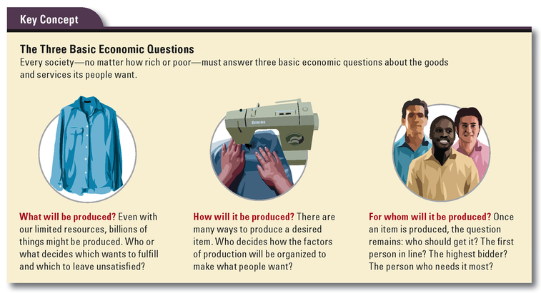

A Society’s Answers Depend on Its Economic Goals
The way a society answers the three economic questions will necessarily depend on its economic aspirations and social values. Most societies try to address some or all of the following six economic goals.

Economic freedom. In our society, we place a high value on economic freedom—the ability to make our own economic decisions without interference from the government. When you choose to buy something, whether it is a music download or a used car, you are exercising this freedom. When you choose to sell your car or go into business selling cars or anything else, you are exercising this freedom. A society that values economic freedom gives individuals and businesses the right to make decisions about how to use their resources, without government intervention.

Economic efficiency. An efficient economy makes the most of society’s resources. It delivers the goods, literally, by allocating resources in such a way that the greatest number of consumers get what they want with the least amount of waste. Because unemployed workers are a wasted resource, an efficient economy strives for full employment, which exists when all who want to work can find jobs.

Economic equity. The term equity concerns fairness and justice. Economic equity involves the fair and just distribution of a society’s wealth. A society that values economic equity seeks to give everyone his or her fair share of the economic pie. But what constitutes a fair share? Is it fair that corporate executives make millions while retail workers earn minimum wage? Is it fair that women, as a group, earn less than men? People often disagree on questions of equity, which makes it a difficult goal to achieve.

Economic growth. An economy is said to grow when it produces more and better goods and services. Economic growth is desirable because over time it leads to an improved standard of living. A century ago, middle-class Americans lived without cars, electricity, kitchen appliances, and indoor plumbing (not to mention antibiotics, frozen foods, and the Internet). A key element of economic growth is scientific and technological innovation. New ideas and inventions bring new and improved products into the market, creating economic growth and raising living standards.

Economic security. Every society has people who cannot provide for themselves. They may be too young, too old, too sick, or too poor to meet all of their basic needs. A society that puts a high value on economic security seeks to provide its less fortunate members with the support they need in terms of food, shelter, and health care to live decently. This is another economic goal about which people often disagree. As Figure 3.2 shows, in the United States, access to affordable health insurance, which most people need to pay for health care, differs greatly from state to state. Even when Americans agree that access to health care should be provided to everyone, they do not agree on how this goal should be accomplished.

Economic stability. No one likes economic uncertainty. Societies therefore strive for its opposite: economic stability. Economic stability means that the goods and services we count on—electricity on demand, food and clothing in the stores—are there when we want them. Our jobs are there when we go to work each day. Prices are predictable, allowing us to plan ahead for purchases.

Most societies consider these goals when making economic choices. But societies differ in the degree of importance they attach to each goal. Sometimes progress toward one goal can be achieved only at the expense of another. For example, when the government taxes our wages in order to pay unemployment benefits, it is contributing to society’s economic security. But it is also encroaching on our economic freedom to control our own resources. Societies, like individuals, must weigh the tradeoffs and opportunity costs of pursuing any particular set of economic goals.

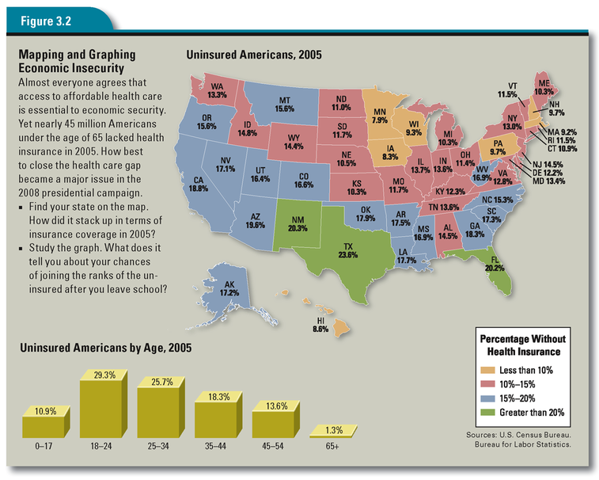

Section 3 Who Decides What in Different Economic Systems?

In the process of answering the three economic questions, every society develops an economic system. An economic system is the way a society coordinates the production and consumption of goods and services. Economic systems are as old as humankind, so you might expect there to be many different models. But if we strip away all the cultural differences that exist between all the societies that ever were, we find that history has produced only three basic types of economic systems. There are those built on tradition, those based on the command of rulers, and those organized by free markets. Each system answers the three economic questions differently. And each emphasizes different economic goals.

Traditional Economies: Decision Making by Custom
The first and oldest economic system is the traditional economy. Traditional economies have existed since the first clans of hunter-gatherers emerged in Africa. In a traditional economy, custom and tradition dictate what to produce, how to produce it, and for whom.

Most traditional economies that survive today belong to indigenous people who live much as their ancestors did hundreds or thousands of years ago. The Maasai of East Africa, for example, are a seminomadic herding people. Livestock, primarily cattle, is the mainstay of their economy. Maasai wealth is measured in cattle and children. The traditional Maasai diet consists primarily of meat, blood, and milk from cattle. The Maasai’s answer to the question of what to produce is cattle, because it is their centuries-old tradition to raise cattle.

As for the question of how to produce, people in traditional economies engage in farming, herding, fishing, hunting, and the gathering of wild plants. Exactly who does what is determined by social customs. Labor is often divided along gender lines. Among the Maasai, for example, men build enclosures to protect the cattle from lions. Boys graze the cattle. Women and girls milk the cattle. Among the Khoi-San people of the Kalahari Desert in Southern Africa, men hunt and women gather.

For whom to produce is another question decided by tradition. Social hierarchies play an important role. A good illustration of this is the way meat is distributed among the Khoi-San people of the Kalahari. After a hunt, the kill is divided up, with a large share going to the hunter. He gives some to relatives, and they give part of theirs to other relatives, all according to the accepted social order. In the end, everyone gets enough to eat.

The highest goals of people in a traditional economy are economic stability and security. Most want nothing more than to live as they always have, following traditional ways of life, in harmony with nature. For most traditional societies, though, this goal is increasingly difficult to attain. Traditional economies have become shrinking outposts of the past surrounded by the modern world. As modern economies exert an ever-growing influence, traditional societies are struggling to find a path to economic survival.

Command Economies: Decision Making by Powerful Rulers

The next economic system to develop is what economists call a command economy. In a command economy, decisions about what, how, and for whom to produce are made by a powerful ruler or some other authority.

The earliest command economies originated in Mesopotamia, Egypt, China, and India about 5,000 years ago. As these civilizations became highly advanced, centralized governments arose that were headed by powerful rulers. These rulers imposed their economic choices on society. This happened even as tradition still guided economic activity at the lower levels of society.

Rulers at the top of these early civilizations—kings, pharaohs, emperors—commanded the populace to devote economic resources to building projects or military adventures. Many thousands of people might be conscripted to build a pyramid, defensive wall, irrigation canal, temple, or road. In a preindustrial age, such projects took vast quantities of human labor. Often, many people would be drafted into a ruler’s army and sent into battle in distant lands.

The primary goal of these ancient command economies was to accumulate wealth and goods for the ruling class while preserving economic stability. The many monuments these societies left behind are a testament to both the productive power of these economies and the excesses of their rulers.

Market Economies: Decision Making by Individuals
The newest economic system to emerge in human history is the market economy. A market economy depends not on tradition or command to coordinate its activities but on the decisions of individual producers and consumers. Note that when economists speak of “the market,” they are referring to the economic system within which buyers and sellers exchange goods and services. This is distinct from an everyday market, which is a place where people buy and sell goods.

In a free market economy, the workings of the market are not planned or directed. No one—no single person, business, or government agency—tells producers or consumers what to do. Economic decisions are made voluntarily, one at a time, by millions of individuals guided by self-interest.

The highest goals of a market economy are economic freedom and efficiency. Individuals and businesses are left at liberty to decide what, how, and for whom to produce. The producers of goods and services make these decisions based largely on consumers’ spending decisions. Because you are free to buy what you want, producers must compete for your dollars. This competition means that you, the consumer, have many choices. It also forces producers to use resources efficiently. If they do not, a competitor will find a way to offer the same good or service at a price that consumers will be more willing to pay.

In a free market, individuals are encouraged to pursue the jobs that allow them to make the most of their human capital. If one employer fails to pay them what they think they are worth, they can quit and seek employment elsewhere. Or they can start their own businesses, perhaps even offering new products or services to consumers.

You might expect that the result of all this individual decision making and competition would be chaos. But as the markets-coordinate-trade principle reminds us, just the opposite is true. Markets are highly efficient at producing a great variety of goods and services that people find attractive and at prices they are willing to pay. It was this coordinating power of markets that Adam Smith famously described as “the invisible hand.” He wrote,

Every individual . . . neither intends to promote the public interest, nor knows how much he is promoting it . . . He intends only his own gain, and he is in this, as in many other cases, led by an invisible hand to promote an end which was no part of his intention . . . By pursuing his own interest he frequently promotes that of the society more effectually than when he really intends to promote it.
—Adam Smith, The Wealth of Nations, 1776

The Flow of Money and Goods in a Market Economy
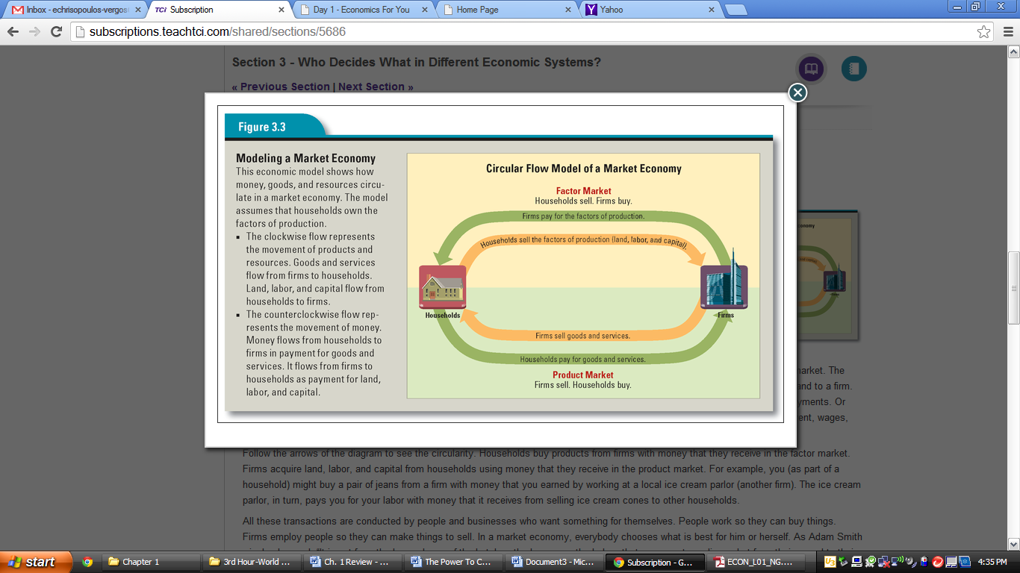

The reason markets work so well is that one per son’s output always becomes another person’s input.

Goods are produced and consumed. Money comes in and goes out. This flow keeps the economy running. Economists use the circular flow model, like that in Figure 3.3, to illustrate these interactions.

In the simplified market economy shown in the model, there are two kinds of participants: households and firms. A household is made up of a person or of a group of people living together. The model assumes that households own the factors of production. A firm is an organization that uses these factors to make and sell goods or services.

The model also shows two kinds of markets. One is the product market, in which goods and services are sold by firms and purchased by households. Your local mall or supermarket is part of the product market. The other is the factor market, in which households sell their land, labor, and capital to firms. A household, for example, might rent land to a firm. Or members of a household might sell their labor to a firm for wages. They might loan money to a firm in exchange for interest payments. Or they might buy a firm’s stock in the hopes of receiving dividend payments. The funds paid to households—whether in the form of rent, wages, interest, or dividends—are known as factor payments.

Follow the arrows of the diagram to see the circularity. Households buy products from firms with money that they receive in the factor market. Firms acquire land, labor, and capital from households using money that they receive in the product market. For example, you (as part of a household) might buy a pair of jeans from a firm with money that you earned by working at a local ice cream parlor (another firm). The ice cream parlor, in turn, pays you for your labor with money that it receives from selling ice cream cones to other households.

All these transactions are conducted by people and businesses who want something for themselves. People work so they can buy things. Firms employ people so they can make things to sell. In a market economy, everybody chooses what is best for him or herself. As Adam Smith wisely observed, “It is not from the benevolence of the butcher, the brewer, or the baker, that we expect our dinner, but from their regard to their own interest.”

Capitalism Gives Rise to Socialism and Communism
Market economies emerged in Europe in the 1700s and began to grow rapidly in the 1800s. This economic growth was a direct result of the Industrial Revolution. During the Industrial Revolution, new inventions and manufacturing processes spurred the growth of industry. Individual investors, called capitalists, grew wealthy by accumulating capital, including machinery, factories, railroads, and the like. The term capitalism came to be synonymous with the free market economic system.

The headlong growth of capitalism had profound effects on society. As more and better goods became widely available, people’s standard of living improved. But capitalism did not improve the quality of life for everybody. The workers who filled the factories and mills labored under harsh conditions. Hours were long, and wages were low. Critics of capitalism blamed the capitalists for exploiting workers and keeping them in poverty.

In 1848, economist Karl Marx and philosopher Friedrich Engels published The Communist Manifesto, in which they advocated the overthrow of capitalism. They proposed an alternative vision of society known as socialism. Socialism is a political and economic philosophy that calls for property to be owned by society as a whole, rather than by individuals, for the equal benefit of all.

To bring about this socialist vision of society, Marx and Engels called on workers everywhere to revolt against their governments. Once the workers had gained power, private property and the free market would be replaced with national ownership of industry and more equal distribution of income.

The final phase of socialism, in the view of Marx and Engels, is communism, a political and economic system in which all property and wealth are owned by all members of society. In a communist society, class differences—and the conflicts they create—disappear. Once that happens, government is no longer needed to keep order. Instead of self-interest, people in a communist society are guided by Marx’s famous slogan: “From each according to his ability, to each according to his needs.”

Modern Command Economies: Decision Making by the State
The ideas of Marx and Engels spurred the development of political movements dedicated to the creation of a workers’ paradise. But when the first successful communist revolution took place in Russia in 1917, it did not lead to the utopian society Marx had envisioned. Instead, the revolutionaries formed an authoritarian government that pursued its socialist goals with brutal force. The renamed Union of Soviet Socialist Republics, or Soviet Union for short, became the first modern command economy.

In the Soviet Union, private ownership of property was forbidden. The state owned the factors of production. Economic planning was done by government committees of economists, production experts, and political officials. These central planning committees attempted to perform the functions of a market. They decided what goods and services should be produced. They decided which farms and factories should get which resources to produce what was planned. Committees also controlled prices and wages and decided how goods and services should be distributed.

In theory, this kind of planning was supposed to ensure economic equity and security—two important goals of a modern command economy. But the reality was very different. The planning committees could not keep track of the millions of products and prices in the Soviet system. Two Soviet economists described what happened when Goskomsten, the committee in charge of prices, raised the price that the government would pay hunters for moleskins.

State purchases increased, and now all the distribution centers are filled with these pelts. Industry is unable to use them all, and they often rot in warehouses before they can be processed. The Ministry of Light Industry has already requested Goskomsten twice to lower purchasing prices, but the “question has not been decided” yet. And this is not surprising. Its members are too busy to decide. They have no time: besides setting prices on these pelts, they have to keep track of another 24 million prices.
—Nikolai Shmelev and Vladmir Popov, The Turning Point: Revitalizing the Soviet Economy, 1990

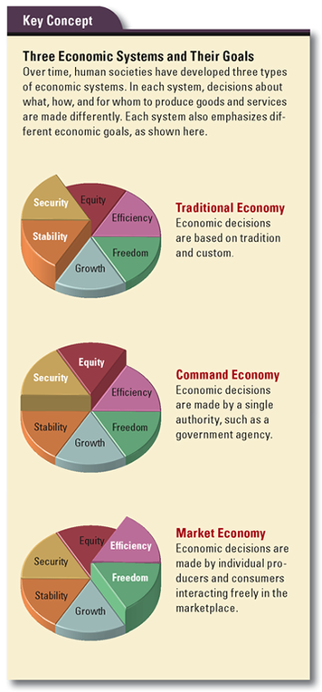
In this planned economy, shortages were common. Long lines would form to buy whatever goods suddenly became available. But once a customer got to the front of that line, choice was limited or nonexistent.

Planners made matters worse by ignoring the incentives-matter principle. The wages paid to workers were determined by government committees, not by a worker’s ability or output. A poor worker could not be fired for slacking off. Nor could a good worker be rewarded for working hard. Under this system, workers had little or no incentive to produce high-quality goods. They also lacked any incentive to innovate in order to increase productivity. As a result, production was slow, and the goods produced were often shoddy, far inferior to those produced in a market economy.

The Soviet Union and other command economies did succeed in increasing economic equity and economic security for their people. But what good is a guaranteed income if there is nothing to buy? What markets do effortlessly, command economies struggle to do, usually with dismal results. Central planning was so inefficient and wasteful that the Soviet Union economy eventually collapsed. Since then, virtually all modern command economies have either failed or struggled to introduce market-based reforms.

Section 4 How Do Mixed Economies Divide the Decision Making?

No country in the world today relies on a purely traditional, market, or command economic system. These systems represent theoretical extremes. Nearly all countries have mixed economies that fall somewhere in between these extremes. In a mixed economy, both the government and individuals play important roles with regard to production and consumption. But who decides what varies from one country to another.

Government’s Role in a Mixed Economy: Protection, Regulation, and Public Benefits
Every nation with a mixed economy forges its own balance between market freedom and government involvement. At the minimum, governments are needed to establish the institutions that enable markets to operate. Such institutions include a legal system to enforce laws and a stable system of currency. Most of us never think about these things, but markets cannot function without them.

In many countries, people expect government to go further. They want it to step in when the market operates in ways that society finds unacceptable. For example, many nations outlaw child labor. Some governments limit the amount of pollution that industries can discharge. In the United States, the government regulates the manufacture of cosmetics, foods, and drugs because consumers want to know that products on the market are safe. Not all governments regulate to the same degree. Each society decides how far it wants its government to go in curtailing the freedom of the market.

Finally, government provides certain goods and services that markets do not always provide or do not provide enough of. Examples include public works, or government-financed projects such as dams, highways, and sewer systems. The market does not provide these goods because, as Adam Smith explained, the cost of providing them “could never repay the expense to any individual or small number of individuals.”

What a government provides varies from country to country. In Canada and much of Europe, health care is provided free to every citizen. Some governments provide free college education or free day care. Governments that provide a high level of goods and services also tax heavily to pay for those goods and services. Again, these are economic choices that every nation makes differently.

The Flow of Goods and Money in a Mixed Economy
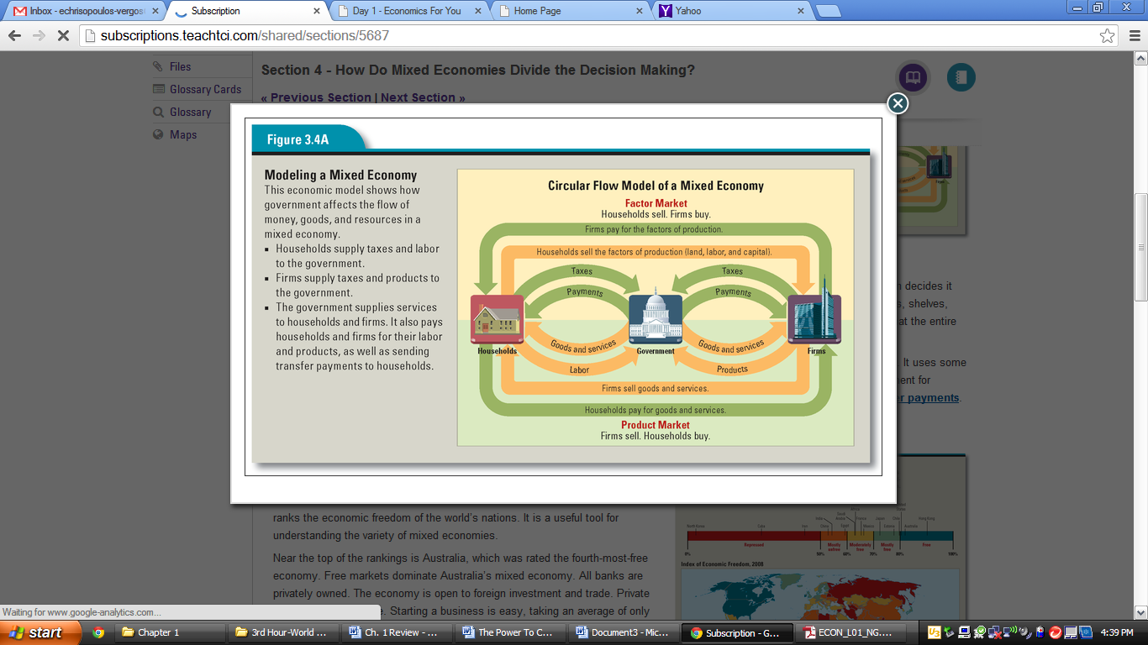

How does government participation in the economy change the flow of money and goods? The answer to this can be seen by adding government to the circular flow model. The revised circular flow model in Figure 3.4A shows a mixed economy with three participants: households, firms, and government.

A government enters the flow of money and products through an economy in a number of ways. It purchases land, labor, and capital from households in the factor market. In the United States, the federal government employs almost 2 million people, making it the nation’s largest employer. A government also purchases goods and services from firms in the product market. As the nation’s largest employer, the federal government is also its largest customer, spending hundreds of billions of dollars a year on goods and services.

Governments also combine land, labor, and capital to produce and distribute goods and services. As an example, suppose a town decides it needs a library. The town government buys land and hires architects and builders in the factor market. Later, the town buys books, shelves, computers, and furniture in the product market. Finally, it hires librarians in the factor market. The end result is a public service that the entire community can enjoy.

Now follow the flow of money in a mixed economy. You will see that a government collects taxes from both households and firms. It uses some of this money to pay for the goods and services it buys from firms. It may also transfer some money back to households as payment for government benefits. Social Security checks, welfare payments, and unemployment benefits are examples of government transfer payments.

The Mixed Economy Continuum: From Free to Repressed
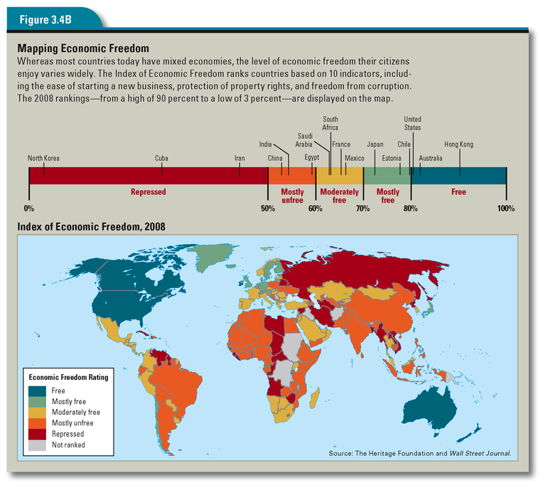

Although most of today’s economies can be described as mixed, the “mix” of market freedom and government control varies greatly from one nation to the next. In 2008, the Heritage Foundation and the Wall Street Journal published their annual Index of Economic Freedom. This index is a kind of scorecard that ranks the economic freedom of the world’s nations. It is a useful tool for understanding the variety of mixed economies.

Near the top of the rankings is Australia, which was rated the fourth-most-free economy. Free markets dominate Australia’s mixed economy. All banks are privately owned. The economy is open to foreign investment and trade. Private property is very secure. Starting a business is easy, taking an average of only two days.

At the very bottom of the list is North Korea, which came in last of the 157 ranked nations. A communist country since 1948, North Korea still has a tightly controlled command economy. The government directs all industries and businesses. Nearly all foreign trade is forbidden. Private property is severely restricted.

What about countries that fall somewhere in between, such as Japan, South Africa, and France? All three have mixed economies dominated by the market system. All have relatively high levels of economic freedom and secure property rights. But they also have high tax rates, which are used to pay for an array of public services and benefits, such as government-provided health care. In these nations, people have decided that achieving economic equity and security for more members of society is worth giving up some measure of their individual wealth.

Further down in the rankings is China, which is rated “mostly unfree.” China, which has had a communist government since 1949, is in transition from a command economy to a market-oriented system. But its mixed economy is still dominated by an authoritarian government. All Chinese banks are owned by the state. Private property is not secure. Internet use is tightly controlled by the government.

Still, China allows more economic freedom than many countries. Iran, for example, is rated “repressed.” Its economy is dominated by the state. The oil and gas industries are owned by the government, as are almost all banks. As in repressed North Korea, foreign investment in Iran is severely restricted. Iran’s legal system does not uphold property rights or contracts.

Only six countries in the 2008 Index of Economic Freedom, plus Hong Kong, were rated “free.” In addition to Australia, these countries are Singapore, Ireland, the United States, New Zealand, and Canada. What do these countries have in common? All have mixed economies dominated by free markets. Most have democratic forms of government. They are also all among the wealthiest nations in the world. As Adam Smith might have predicted, the societies with the most economic freedom are also among the most prosperous.

Section 5 What Are the Key Characteristics of the U.S. Economic System?

The high ranking of the United States on the Index of Economic Freedom is not surprising. Americans dearly value their economic freedom, so much so that we even describe our economy as a free enterprise system. In a free enterprise system, individuals own the factors of production and make decisions about how to use those factors within the framework of the law. Seven key characteristics of a free enterprise system are explored below.

Economic Freedom
As the term free enterprise suggests, the essence of our nation’s economic system is freedom—the ability of individuals to act in their own best interest in free markets. In practical terms, this means we can buy what we want and from whom we want. If we do not like what one firm is selling, we can take our business elsewhere. We are free to start businesses or to seek any job we choose. Firms are free to make what they want, hire whomever they choose, and set their own wages and prices.

Because our economic system allows individuals and businesses so much freedom, it is often referred to as a laissez-faire economy. Economists use the term laissez-faire to describe a market economy that is relatively free of government intervention. (In French, laissez-faire means “let them do.”) But in fact, laws exist that limit what producers and consumers can do in this country. Stores are not free to sell alcohol to teenagers. Businesses are not free to hire child laborers. Economic freedom does not give anyone the right to break the law. But it does allow us to act in our economic best interest within the law.

Competition
Because virtually anyone can enter the market at any time, many rival sellers usually vie for customers’ business. The resulting competition is a hallmark of the free enterprise system.

Competition provides an incentive for businesses to create new and better products and ways of serving customers. For consumers, this means more goods and services to choose from. Competition also encourages producers to use their resources efficiently in order to lower costs. When lower costs translate into lower prices, consumers win again.

Equal Opportunity
In 1776, the Declaration of Independence declared,
We hold these truths to be self-evident, that all men are created equal, that they are endowed by their Creator with certain unalienable Rights, that among these are Life, Liberty and the pursuit of Happiness.

Most Americans today understand these words to mean that we are born equal in terms of our rights, freedoms, and the opportunity to make the best of our talents and abilities. Our belief in the United States as a “land of opportunity” is deeply rooted in our country’s history as a nation of immigrants.

Nonetheless, our free enterprise system has not always offered equal opportunity to everyone. Women, African Americans, and other minority groups have had to fight discrimination in education and employment. Through the efforts of citizens and government intervention, these barriers to economic opportunity have fallen. Today every citizen has the same legal right to gain an education and compete in the marketplace.

Binding Contracts
In business, a contract is an agreement between a buyer and a seller. Contracts are used in all kinds of economic transactions. Even the slip of paper you sign when you use a credit card is a contract. In our free enterprise system, people are free to decide what contracts they want to enter into—but once agreed on, a contract is binding. That means both sides have to fulfill their ends of the deal.

Because free enterprise depends on buyers and sellers honoring their agreements, it is important to have a legal system that upholds contracts. U.S. courts recognize the binding nature of contracts. They also recognize that people and businesses can run into financial problems and become unable to pay their debts. Bankruptcy is the legal process by which such situations can be resolved.

Property Rights
A necessary element of a free enterprise system is the right to own property. Property rights are the rights of those who own land, buildings, or other goods to use or dispose of them as they choose.

In other countries, past and present, rulers have had the power to seize another person’s property for their own use. The U.S. Constitution protects against this abuse of power. It guarantees access to the courts in case of disputes about property. It further guarantees that an owner will be paid for property that is taken by the government for public use. These constitutional guarantees are crucial to the free market. Why would people buy homes or start businesses, unless they were certain they would get to keep their property?

The Constitution also provides for the protection of intellectual property by empowering Congress to enact patent and copyright laws. Intellectual property refers to creations of the mind that have commercial value. A patent gives an inventor the sole right to make, use, or sell his or her invention for 20 years. A copyright similarly gives the creator of a literary or artistic work the sole right to reproduce, distribute, perform, or display the copyrighted work. Current copyrights last for 70 years beyond the life of the author.

Why do we need intellectual property laws? Think about what would happen without them. As soon as a new invention (or book or song) became public, others would copy it and put it on the market. The inventor (or writer or composer) would get no reward for his or her efforts. Without a reward, inventors and creative individuals would have no incentive to invent new things or create new works. Patents and copyrights encourage creativity and innovation by guaranteeing that inventors and artists can profit from their creations.

Profit Motive
If any one force could be said to drive a free enterprise system, it is the profit motive. Profit is the money earned by a business after subtracting its costs of operation. The desire to make a profit is known as the profit motive. The profit motive is closely tied to the incentives-matter principle. Profits are our incentive to work or start businesses in the hope of making money for ourselves.

Some people confuse the profit motive with greed or with stealing wealth from others. Most economists, however, see the profit motive as a positive force in society. It is, they remind us, the reason most businesses exist. As Adam Smith observed, people produce goods and services not out of the kindness of their hearts, but in order to improve their economic situation—to make a profit.

Limited Government
The final key characteristic of a free enterprise system is a relatively limited role for government in the economy. In the United States, the government does not try to control firms. Nor does it often compete with firms. Government intervention in the economy is generally limited to seven areas.

Protecting property rights and contracts. The government enforces laws that protect property owners and patent and copyright holders.
Promoting the general welfare. The government funds projects and programs that benefit society as a whole.
Preserving competition. The government enacts laws that protect and preserve a competitive marketplace.
Protecting consumers, workers, and the environment. The government requires businesses to ensure that their products do not harm consumers. It also imposes regulations on firms to promote workplace safety and reduce pollution.
Stabilizing the economy. The government works to keep the economy growing steadily rather than alternating between periods of boom and bust.

Looking at these seven characteristics of a free enterprise system brings us back to the question we started with: Who or what decides what you get? In our economic system, the answer is both a who and a what. The what is the market, made up of millions of individuals who buy and sell goods every day on a strictly voluntary basis. The who is you, your family, and your friends, all exercising your freedom of choice as consumers. In the chapters ahead, you will learn more about how the choices you and others make in the market help determine what you might get tomorrow.

Summary

Because resources are always scarce compared to people’s wants, all societies must make choices about what to have and what to give up. How those choices get made depends on a society’s economic system.

How do societies decide who gets what ?Every society is faced with three economic questions: What goods and services should be produced? How should they be produced? Who should get what is produced? How a society answers those questions depends on its economic goals. These goals include economic freedom, efficiency, equity, growth, security, and stability.

Who decides what in different economic systems? Over time, societies have developed three economic systems to answer these questions. In a traditional economy, decisions are dictated by custom and the ways of ancestors. In a command economy, a powerful ruler or government makes decisions. In a market economy, decisions are made by the interactions of individual producers and consumers. Each system emphasizes different economic goals.

How do mixed economies divide the decision making? Most countries today have a mixed economy, in which both the government and individuals have a voice in economic decisions. Who decides what varies greatly. Some countries, including the United States, minimize government regulation of the market. Others, such as China, still exercise considerable government control over economic activities.

What are the key characteristics of the American economic system? Americans describe their economy as a free enterprise system. This system has seven key characteristics.

• Economic freedom to buy and sell what we want and work where we want
• Competition among firms, which try to attract customers with new and better products
• Equal opportunity to make the best use of our talents, abilities, and education
• Property rights that allow us to buy, own, and sell goods and intellectual property
• Binding contracts, which give us confidence that others will abide by their agreements
• The profit motive, which provides an incentive to work and start new businesses
• Limited government that regulates without controlling individuals, firms, or the market

